

SAFEGRID-AI: AN EXPLAINABLE MULTI-AGENT SYSTEM FOR DYNAMIC POWER ROUTING
A neuro-symbolic multi-agent controller with a deterministic safety shield and operator-facing explanations
A project report submitted in partial fulfilment of the requirements for the award of the degree of
BACHELOR OF TECHNOLOGY
in
COMPUTER SCIENCE AND ENGINEERING
Submitted by
DISHA KAUSHAL | 23K91A0563
BOLLAM RAKESH | 23K91A0542
CHINNOLLA RAVINDHAR | 23K91A0554
AFFAN MOHAMMED RAMY | 23K91A0505

Batch A13 (CSE-A)
Under the esteemed guidance of
CHANDRASHEKAR
[DESIGNATION]
DEPARTMENT OF COMPUTER SCIENCE AND ENGINEERING
TKR COLLEGE OF ENGINEERING AND TECHNOLOGY (AUTONOMOUS)
[COLLEGE ADDRESS / AFFILIATING UNIVERSITY]
Academic year [ACADEMIC YEAR]

CERTIFICATE
This is to certify that the project report entitled "SafeGrid-AI: An Explainable Multi-Agent System for Dynamic Power Routing" is a bonafide record of the work carried out by DISHA KAUSHAL (23K91A0563), BOLLAM RAKESH (23K91A0542), CHINNOLLA RAVINDHAR (23K91A0554), AFFAN MOHAMMED RAMY (23K91A0505), in partial fulfilment of the requirements for the award of the degree of Bachelor of Technology in Computer Science and Engineering, during the academic year [ACADEMIC YEAR], under my supervision.

Project Guide | Head of the Department | Principal
CHANDRASHEKAR | [HOD NAME] | [PRINCIPAL NAME]
[DESIGNATION] | Department of Computer Science and Engineering | TKR College of Engineering and Technology (Autonomous)

External Examiner: [NAME AND SIGNATURE]
Place: [CITY]
Date: [DATE]

DECLARATION
We hereby declare that the project report entitled "SafeGrid-AI: An Explainable Multi-Agent System for Dynamic Power Routing", submitted to the Department of Computer Science and Engineering, TKR College of Engineering and Technology (Autonomous), in partial fulfilment of the requirements for the award of the degree of Bachelor of Technology in Computer Science and Engineering, is a record of original work carried out by us under the guidance of CHANDRASHEKAR, [DESIGNATION]. The software, the experiments and the figures reported here were produced by running the project's own code, and the sources we rely on are cited in the references. The results embodied in this report have not been submitted to any other university or institution for the award of any degree or diploma.

DISHA KAUSHAL 23K91A0563
BOLLAM RAKESH 23K91A0542
CHINNOLLA RAVINDHAR 23K91A0554
AFFAN MOHAMMED RAMY 23K91A0505

Place: [CITY]
Date: [DATE]

ACKNOWLEDGEMENT
We express our sincere gratitude to our project guide, CHANDRASHEKAR, [DESIGNATION], for valuable guidance, encouragement and constructive suggestions throughout this project.
We thank [HOD NAME], Head of the Department of Computer Science and Engineering, for providing the facilities and support needed to complete this work, and [PRINCIPAL NAME], Principal, TKR College of Engineering and Technology (Autonomous), for the encouragement given to us.
We thank the project coordinators and all faculty and staff members of the department for their help, and our families and friends for their constant support.
We also acknowledge the authors of the base paper and of the supporting papers on LLM-based grid control, and the developers of the open-source software on which the project stands: pandapower, FastAPI, pydantic, numpy, scipy, SQLite, React, Vite, three.js, matplotlib, pytest and Playwright.

DISHA KAUSHAL
BOLLAM RAKESH
CHINNOLLA RAVINDHAR
AFFAN MOHAMMED RAMY

ABSTRACT
Power networks that host rooftop solar, batteries and electric vehicles must keep voltages, cable currents and transformer loading inside their limits while generation and demand change every few minutes. Fixed rules do not adapt, and language-model agents that do adapt can, in principle, emit a wrong or unauthorised command to physical equipment. This project, SafeGrid-AI, builds an explainable multi-agent controller for a simulated three-node low-voltage feeder in which every action proposed by an agent must pass a deterministic Symbolic Safety Shield before it is executed. Three agents perceive a structured context and obtain one schema-validated action from a pluggable provider; a coordinator detects conflicting proposals; the shield approves a proposal, scales it down to the largest safe value by bisection on trial AC power flows, or rejects it; only validated set-points are committed to the pandapower model. Every decision is explained from structured facts, without chain-of-thought text, and non-approved actions are written to a SHA-256 hash-chained log.
The system was evaluated on seven seeded scenarios, three control strategies (a rule baseline, the agents without the shield, and SafeGrid-AI) and three seeds, in 63 simulation runs. Across 21 shielded runs (1,512 agent proposals) the shield approved 1,162 (76.9 %), projected 237 (15.7 %) and rejected 113 (7.5 %), and no executed action created or worsened a limit violation (0 of 504 steps), whereas the same agents without the shield did so in 99 steps (144 violations). The shield does not repair stress that is already present on the grid when every agent is idle, so steps with any violation fall from 6.05 (rule baseline) and 6.38 (agents without the shield) to 2.48 (SafeGrid-AI) per 24-step run, not to zero. Safety has a price: the mean step time rises from about 108 ms to 348 ms because of the trial power flows, and renewable utilisation is 0.86 against 1.00 for the baseline.
The results have clear limits. Every agent result comes from a deterministic mock provider; a real-LLM provider is implemented but was not run against a live model, so language-model reasoning quality and real inference latency are unmeasured. The feeder is synthetic, only three seeds were used, no violation-resolution rate was measured, the guarantee is relative to the simulated model and not a formal proof, and the comparison with the base paper (a rule-based DC microgrid study) is qualitative. 52 of 55 automated tests pass; two numeric-tolerance tests fail and one WebSocket test hangs. The system is a research prototype, not a control product.
Keywords: agentic AI, large language models, multi-agent systems, smart grid, neuro-symbolic safety, safety shielding, explainability, power flow.

TABLE OF CONTENTS
CERTIFICATE i
DECLARATION ii
ACKNOWLEDGEMENT iii
ABSTRACT iv
TABLE OF CONTENTS vi
LIST OF FIGURES xi
LIST OF TABLES xiii
LIST OF ABBREVIATIONS xv
CHAPTER 1: INTRODUCTION 1
1.1 Introduction to the Project Domain 1
1.2 Background and Motivation 1
1.3 Problem Statement 2
1.4 Need for the Proposed System 3
1.5 Project Objectives 3
1.6 Scope of the Project 4
1.7 Project Contributions 5
1.8 Limitations and Assumptions 5
1.9 Organization of the Report 6
CHAPTER 2: LITERATURE SURVEY 7
2.1 Overview 7
2.2 Base Paper Analysis 8
2.3 LLM-Based and Agentic Grid Control 9
2.4 Multi-Agent and Reinforcement-Learning Energy Management 9
2.5 Safe Learning, Shielding and Auditability 10
2.6 Simulation Tools and Algorithms Used in Related Work 10
2.7 Strengths and Limitations of Existing Research 11
2.8 Research Gap 12
CHAPTER 3: FEASIBILITY STUDY 13
3.1 Technical Feasibility 13
3.2 Economic Feasibility 14
3.3 Operational Feasibility 14
3.4 Schedule Feasibility 15
3.5 Advantages and Constraints 15
CHAPTER 4: SYSTEM REQUIREMENTS AND ANALYSIS 16
4.1 Existing System 16
4.2 Limitations of the Existing System 16
4.3 Proposed System 16
4.4 Advantages of the Proposed System 17
4.5 Functional Requirements 18
4.6 Non-Functional Requirements 18
4.7 Hardware Requirements 19
4.8 Software Requirements 19
4.9 User Roles and System Constraints 20
CHAPTER 5: SYSTEM DESIGN 21
5.1 Overall System Architecture 21
5.2 High-Level Workflow 22
5.3 Data Flow Diagrams 23
5.4 UML Diagrams 25
5.5 Entity-Relationship Diagram 27
5.6 Database Schema and Table Descriptions 27
5.7 Module Architecture 28
5.8 Shield Decision Workflow 29
CHAPTER 6: METHODOLOGY AND SOFTWARE IMPLEMENTATION 32
6.1 Overall Methodology 32
6.2 Simulated Data and Scenarios 33
6.3 Perception: Building the Agent Context 34
6.4 Algorithm Selection and Justification 34
6.5 Mathematical Formulation 35
6.6 Agents, Providers and Fallback 37
6.7 Symbolic Safety Shield and Projection 37
6.8 Coordinator 39
6.9 Explanations 39
6.10 Application Architecture and Implementation 39
6.11 API Design 40
6.12 Security, Privacy and Error Handling 41
CHAPTER 7: SYSTEM TESTING 42
7.1 Testing Strategy 42
7.2 Unit Testing 42
7.3 Integration Testing 44
7.4 Functional and System Testing 44
7.5 Security Testing 45
7.6 Validation and Edge Cases 46
7.7 Performance Testing 46
7.8 User Acceptance Testing 47
7.9 Testing Limitations 47
CHAPTER 8: RESULTS AND OUTPUT SCREENS 49
8.1 Application Output Screens 49
8.2 Experimental Setup 53
8.3 Violations Caused by Executed Actions 54
8.4 What the Shield Decided 55
8.5 Pre-existing Grid Stress 56
8.6 Cost of Safety 58
8.7 Single-Run Traces 59
8.8 Analysis of Successful and Failure Cases 60
8.9 Discussion of Limitations 61
8.10 Objectives versus Outcomes 61
8.11 Comparison with the Base Paper 62
CHAPTER 9: CONCLUSION 63
9.1 Summary of the Work 63
9.2 Objectives Achieved and Main Contributions 63
9.3 Key Findings 63
9.4 Practical Applications 64
9.5 Known Limitations 64
CHAPTER 10: FUTURE SCOPE 66
10.1 Possible Improvements 66
10.2 Additional Features 66
10.3 Scalability and Deployment 67
10.4 Further Research Directions 67
REFERENCES 69
APPENDIX A: IMPORTANT CODE 71
A.1 The action schema (`models/actions.py`) 71
A.2 Shield evaluation, steps 1 to 3 (`safety/shield.py`) 71
A.3 Shield evaluation, step 4: projection (`safety/shield.py`) 72
A.4 Bisection (`safety/projector.py`) 72
A.5 Hash-chained safety events (`safety/events.py`) 73
A.6 Sequential validation and commit (`simulation/engine.py`) 73
APPENDIX B: INSTALLATION AND USER GUIDE 74
B.1 Requirements 74
B.2 One-click start (Windows) 74
B.3 Manual start 74
B.4 Using the console 75
B.5 Running a strategy comparison 75
B.6 Running the checks 75
B.7 Using a real language model 76
B.8 Troubleshooting 76
APPENDIX C: ADDITIONAL SCREENS 77

LIST OF FIGURES
Figure 1: The simulated three-node low-voltage feeder used throughout the project 3
Figure 2: SafeGrid-AI places a deterministic shield between the agents and the grid (overview, detailed in Chapter 5) 12
Figure 3: Workflow of one simulation step in the proposed system 17
Figure 4: System architecture of SafeGrid-AI 21
Figure 5: High-level workflow of one simulation step (15 simulated minutes) 22
Figure 6: Data flow diagram, level 0 (context diagram) 23
Figure 7: Data flow diagram, level 1 24
Figure 8: Data flow diagram, level 2: process 4.0 expanded 24
Figure 9: UML class diagram of the backend (backend/app) 25
Figure 10: Sequence diagram: one simulation step 26
Figure 11: Use-case diagram 26
Figure 12: Entity-relationship diagram of the SQLite store 27
Figure 13: Core algorithm: Symbolic Safety Shield evaluate() 29
Figure 14: Simulated low-voltage feeder (pandapower network) 30
Figure 15: Hash-chained safety log 31
Figure 16: Median and 95th-percentile latency of the live API calls 47
Figure 17: Dashboard after a completed run of the unsafe-action scenario 49
Figure 18: Grid view: single-line diagram of the feeder 50
Figure 19: Agent monitor: the three agents and the latest decision 50
Figure 20: Safety shield: dry run of a 1,000 kW export, and the active constraints 51
Figure 21: Power flow: bus voltages and line loadings over the run 52
Figure 22: Scenarios: result of the strategy comparison 52
Figure 23: Explainability: proposal, shield decision and executed action for one agent 53
Figure 24: Steps with violations caused by actions, per scenario and strategy (mean of three seeds) 55
Figure 25: Approved, projected and rejected proposals per run and scenario (SafeGrid-AI arm) 56
Figure 26: Grid stress with every agent idle compared with violations after SafeGrid-AI actions 57
Figure 27: Steps with any violation after execution, per scenario and strategy 57
Figure 28: Overall comparison: violations after execution, cost, renewable utilisation and step time 58
Figure 29: Energy cost and renewable utilisation per scenario 58
Figure 30: Single-run traces with and without the shield: line loading, highest bus voltage and lowest bus voltage 59
Figure 31: Landing page (dark theme) with the three.js hero 77
Figure 32: Landing page in the light theme 77
Figure 33: The "How it works" section: the ten ordered shield checks 78
Figure 34: Sign-in screen with the demo account 78

LIST OF TABLES
Table 1: Abbreviations used in this report xv
Table 2: Literature survey comparison 7
Table 3: Base paper compared with SafeGrid-AI (qualitative) 8
Table 4: Technical risks and mitigations 13
Table 5: Development resources and cost incurred (INR) 14
Table 6: Project schedule by review phase 15
Table 7: Functional requirements 18
Table 8: Non-functional requirements and the evidence for each 18
Table 9: Hardware requirements (measured machine) 19
Table 10: Software requirements (versions used) 19
Table 11: Table runs 27
Table 12: Table events 28
Table 13: Table safety_events 28
Table 14: Table steps 28
Table 15: Table experiments 28
Table 16: Backend modules and their size 29
Table 17: Evaluation metrics as computed by the engine 32
Table 18: The seven scenarios 33
Table 19: LLM providers 37
Table 20: The ten shield checks (25 violation codes) 38
Table 21: API endpoints 40
Table 22: Backend test files and what they cover 42
Table 23: Edge cases and expected behaviour 46
Table 24: Live API latency (milliseconds) 46
Table 25: Experimental setup 53
Table 26: Overall comparison of the three strategies (mean per run of 24 steps; 21 runs per strategy) 54
Table 27: Steps with violations caused by actions, per scenario (mean of three seeds, of 24 steps) 54
Table 28: Shield decisions per scenario, SafeGrid-AI arm (mean per run of three seeds) 55
Table 29: Steps with any violation after execution, per scenario (mean of three seeds, of 24 steps) 56
Table 30: Energy cost per run (INR, illustrative tariff) and renewable utilisation, per scenario 58
Table 31: Worst values in the three traced runs 59
Table 32: Objectives of the project and what was delivered 61
Table 33: SafeGrid-AI compared with the base paper (qualitative) 62
Table 34: Console screens 75
Table 35: Common problems 76

LIST OF ABBREVIATIONS
Table 1: Abbreviations used in this report
Abbreviation | Expansion
AC | Alternating Current
API | Application Programming Interface
ASGI | Asynchronous Server Gateway Interface
CORS | Cross-Origin Resource Sharing
CSV | Comma-Separated Values
DC | Direct Current
DER | Distributed Energy Resource
DFD | Data Flow Diagram
EMS | Energy Management System
ER | Entity-Relationship
EV | Electric Vehicle
HTTP | Hypertext Transfer Protocol
JSON | JavaScript Object Notation
LLM | Large Language Model
LV | Low Voltage
MAS | Multi-Agent System
MCP | Model Context Protocol
MV | Medium Voltage
pu | per unit (fraction of nominal voltage)
PV | Photovoltaic
REST | Representational State Transfer
SHA-256 | Secure Hash Algorithm, 256-bit
SOC | State of Charge
SPA | Single-Page Application
SQL | Structured Query Language
TSO | Transmission System Operator
UI | User Interface
UML | Unified Modeling Language
WebSocket | Full-duplex communication protocol over a single TCP connection

CHAPTER 1: INTRODUCTION

1.1 Introduction to the Project Domain
An electricity distribution network has to match generation and demand at every instant while keeping voltages, cable currents and transformer loading inside the limits that the equipment and the supply standards allow. For most of the twentieth century a few large generators fed passive consumers and fixed operating rules were enough. Rooftop solar, community batteries and electric vehicles now turn many consumers into prosumers who both draw and inject power, the injections depend on weather, and the direction of flow on a street-level feeder can reverse within minutes [10]. A small cluster of generation, storage and load operated as one controllable unit is usually called a microgrid [9].
Two ideas from computer science meet this problem. The first is the multi-agent system: instead of one central controller, autonomous software agents each perceive part of the system, decide for their own device or node, and coordinate with the others [18]; it is a natural fit for distributed energy resources and has long been studied in power engineering [8]. The second is the large language model (LLM) used as an agent: given the state of a system as structured text, it can propose an action, choose a tool and justify the choice [16], which fixed rules and classical optimisers do not do naturally.
This project, SafeGrid-AI, combines the two and adds a third element: every action proposed by an agent passes through a deterministic Symbolic Safety Shield before it can touch the grid. The shield is ordinary code, independent of any language model, that checks the proposal against the physical and operational limits, executes it as requested if it is safe, scales it down to the largest safe value if it is not, and rejects it if no safe value exists. Because the agent is only a proposer, the same architecture works with a scripted agent, a mock model or a real LLM, and the safety argument does not depend on how well the model behaves. The environment is a simulated three-node low-voltage feeder solved with the pandapower AC power-flow library [11].

1.2 Background and Motivation
Recent work shows how far LLM-driven agents can go in power systems. Grid-Agent couples a planning agent that uses power-flow solvers with a validation agent that executes actions in a sandbox with rollback, and reports success rates of up to 100 % for the best model configurations on IEEE 69-bus, CIGRE medium-voltage and IEEE 30-bus networks, although weaker configurations reach only 63 % and 44 % [2]. A position paper from a transmission operator proposes exposing a grid simulator to AI agents through the Model Context Protocol, with traceability and human oversight [3]. The base paper of this batch designs a multi-agent energy management system for a DC microgrid with four rule-based agents and shows in simulation that the bus voltage stays at 800 V in eight operating scenarios [1].
Together these papers leave a gap. The rule-based system is safe by construction of its rules but cannot adapt or explain a decision in operator language. The LLM-based systems adapt, but their safety rests on trial execution and rollback rather than on a rule layer independent of the model, and a probabilistic model that emits a tool call to physical equipment can, in principle, emit a wrong or unauthorised one. Avoiding unintended side effects and unsafe exploration are listed among the concrete open problems of AI safety [15]. In reinforcement learning, shielding corrects actions that would violate a specification [12], and a safety layer can project an action onto the set of safe actions [13]; surveys describe both families [14]. We transfer the same idea to an agentic grid controller, with the shield operating on a physical network model.
Explainability is the second motivation. An operator who cannot ask why a battery was discharged will not trust the controller. Narrations produced by a language model can misrepresent the real reasons for an answer [17], so SafeGrid-AI builds its explanations from structured facts the system itself knows: the inputs the agent saw, the factors that drove the choice, the action, and the shield's verdict with the violated limits. No chain-of-thought text is requested or stored.

1.3 Problem Statement
Given the observed state of a low-voltage feeder with distributed solar, batteries and an electric vehicle, let several autonomous agents propose power set-points at every control step, and execute only set-points that cannot create or worsen a violation of voltage, line, transformer, battery or import/export limits, while recording a reviewable explanation and an audit trail for every decision.
The batch problem statement lists four weaknesses of current practice that this formulation addresses; the need is an explainable multi-agent controller that routes power dynamically while a safety layer blocks any unsafe action:
• Fixed-rule grid control cannot adapt to renewable variability or changing topology.
• Centralised control creates a single point of failure for the whole network.
• Autonomous agents acting on physical infrastructure can take unsafe actions if unconstrained.
• Operators will not accept control decisions they cannot interrogate.

1.4 Need for the Proposed System
• Adaptivity. Fixed rules do not follow cloud cover, price changes or an unusual load pattern; agents that read the current context can.
• Containment of unsafe actions. An agent can propose an action that overloads a line or pushes a voltage out of band; the shield makes that impossible to execute rather than unlikely.
• Distributed decisions. Each agent decides for its own node, so the loss of one agent degrades only that node; a failed or malformed proposal is replaced by a labelled deterministic fallback and is still shielded.
• Auditability. Every intervention is written to a hash-chained log, so what was proposed and what was executed can be checked for tampering [20].
• Evidence before deployment. An AI controller has to be measured on seeded, repeatable scenarios, including deliberately unsafe proposals, before anyone considers connecting it to equipment.
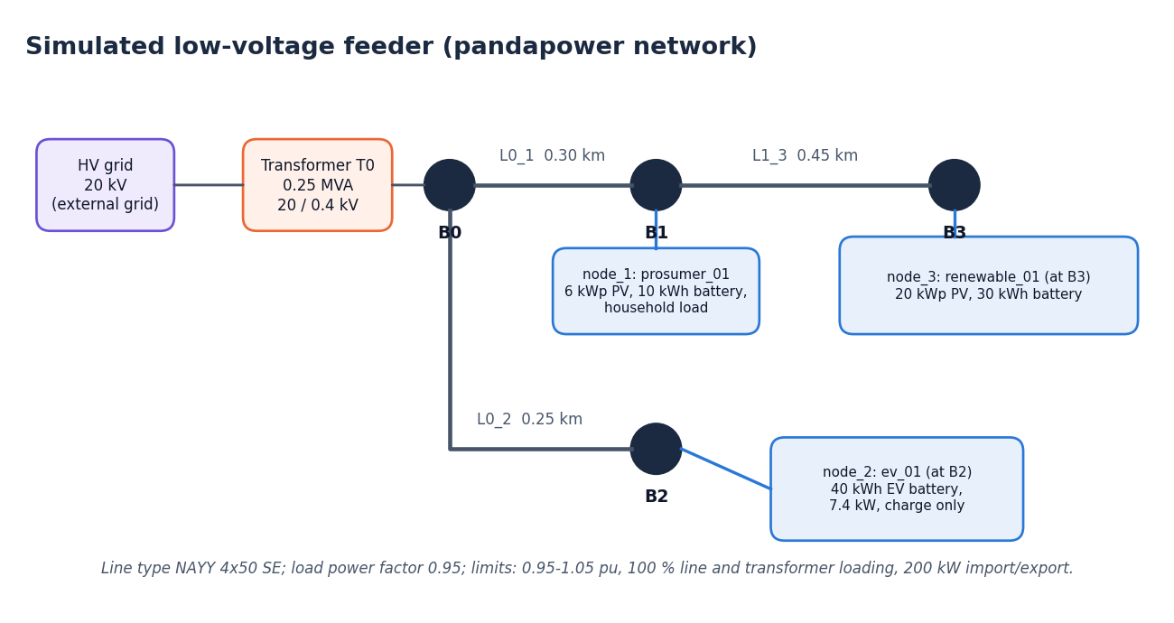
Figure 1: The simulated three-node low-voltage feeder used throughout the project

1.5 Project Objectives
The objectives are those recorded in the batch objectives document:
1. Model the grid as a multi-agent system with agents responsible for generation, storage and load.
2. Implement an LLM-driven planning agent that proposes routing actions from observed grid state.
3. Add a safety shielding layer that validates each action against physical and operational constraints.
4. Provide explanations for every routing decision so operators can audit the reasoning.
5. Simulate fault and overload scenarios to test dynamic rerouting behaviour.
6. Evaluate violation resolution rate, decision latency and the number of unsafe actions blocked.
Section 8.10 compares each objective with what was delivered: objectives 1 to 5 were achieved (objective 2 with a mock model in place of a live LLM), and objective 6 in part, since unsafe actions blocked and decision latency were measured but a violation-resolution rate was not.

1.6 Scope of the Project

In scope
• A software-only simulation of a three-node 0.4 kV feeder with a household prosumer, an electric-vehicle charger and a renewable prosumer, solved with AC power flow in 15-minute steps.
• Three agents with a pluggable provider interface (mock, API-based LLM, rule-based, failing) and a deterministic fallback policy.
• A coordinator for conflicting proposals, and the Symbolic Safety Shield with ten ordered checks and bisection projection.
• Seven seeded scenarios, including injected unsafe and malformed proposals, and a three-strategy comparison.
• A FastAPI service (REST and WebSocket), SQLite persistence, a hash-chained safety log and a React dashboard.

Out of scope
• Connection to real equipment, real measurements or a real network operator; protection, dynamics and three-phase unbalance.
• Training or fine-tuning of any model; no dataset is used, since the inputs are generated from a seed.
• Evaluation with a live language model, and a user study with operators.
• A formal proof of safety; the guarantee we claim is relative to the simulated model.

1.7 Project Contributions
• A model-independent safety path for agentic power control. The shield reads only the structured action and the grid model, never prompts or model text, and a test enforces that it imports nothing from the language-model, agent, simulation or grid packages.
• Approve, project or reject. The shield scales unsafe actions to the largest safe value by bisection on trial power flows, so the agent's intent is kept as far as safety allows.
• Attribution of violations. Only violations that are new or worse than the grid state with every agent idle are blamed on an action.
• Conflict-aware coordination. Peer mismatch, target contention and shared-feeder conflicts are detected, and relief actions are validated first.
• Structured, auditable explanations. Each decision carries its inputs, factors, action and safety result, and every non-approved action is chained into a tamper-evident log.
• A measured evaluation. Across 63 runs the shield approved 1162 of 1,512 proposals (76.9%), projected 237 (15.7%) and rejected 113 (7.5%); executed actions caused no limit violation in any of the 504 shielded steps, against 99 steps without the shield.

1.8 Limitations and Assumptions
The results of this report have to be read with the following limitations in mind; Chapter 8 and the Scope and Limitations document discuss them in detail.
• Every agent result comes from the deterministic mock provider; no live language model was evaluated, so language-model reasoning quality and real inference latency are unmeasured.
• The batch objective 'violation resolution rate' was not measured; the project measures violations prevented (caused by actions = 0) and steps with any violation, not repair of a grid that is already outside its limits.
• Mean decision latency is 0.1-0.2 ms for the mock provider and says nothing about a real model.
• Three seeds, a three-node synthetic feeder, an illustrative tariff, no protection, no dynamics and no three-phase unbalance.
• The guarantee is model-relative (no new or worse violations in the simulated model), not a formal proof; the abstract's 'mathematically guaranteeing zero physical constraint violations' is stronger than what was built and tested.
• The comparison with the base paper is qualitative: different system, no shared benchmark, no like-for-like numbers.
• Two unit tests fail on numeric tolerances with pandapower 3.5.6 and one WebSocket test hangs under the installed Starlette test client.
• No user study was carried out, so usability and operator trust are not measured.
We assume that the three-node feeder, the seeded profiles and the illustrative time-of-use tariff are representative enough to exercise the controller, that the pandapower AC power flow is an acceptable network model for 15-minute steps, and that the limits (0.95 to 1.05 per unit, 100 % loading of lines and transformer, 200 kW import and export) are the limits the operator wants enforced. Costs are in rupees at an illustrative tariff and are used only to compare strategies.

1.9 Organization of the Report
• Chapter 2 surveys the base paper and related work and states the research gap; Chapter 3 assesses feasibility; Chapter 4 describes the existing and proposed systems and lists the requirements.
• Chapter 5 presents the design (architecture, workflow, data flow and UML diagrams, database, core algorithm); Chapter 6 explains the methodology and implementation.
• Chapter 7 describes the testing, including the failing tests; Chapter 8 presents the output screens and measured results, and compares objectives with outcomes.
• Chapter 9 concludes and Chapter 10 lists future work. The references and three appendices (important code, installation and user guide, additional screens) follow.

CHAPTER 2: LITERATURE SURVEY

2.1 Overview
The survey covers four strands of work: multi-agent energy management in microgrids, large language models as grid-control agents, safe learning and action shielding, and the open-source tools used to simulate distribution networks. The batch literature survey lists five papers, the first being the base paper [1]. We read the base paper in full, and two supporting papers kept in the batch folder: Grid-Agent [2] and a position paper on agentic grid studies with the Model Context Protocol [3]. The other four papers of the batch survey [4]-[7] are known by title, year and venue only; we classified them from those and did not read them in full, so nothing is claimed about their method or results beyond what the title states. Four classic references [8][9][10][18] give the background.
Table 2: Literature survey comparison
Work | Approach | Setting | Reported result or stated limit
Eyimaya and Altin, 2026 [1] (base paper) | Four rule-based agents (DER, energy storage, load, grid) coordinate a DC microgrid | MATLAB/Simulink, 800 V DC bus, PV, wind, generator, battery, critical and non-critical loads; 20 microsecond sampling | Bus voltage held at 800 V and critical loads supplied in all eight operating scenarios; authors name scalability, software integration, cybersecurity and missing experimental validation as open issues
Zhang et al., 2025 [2] | LLM planning agent proposes actions with power-flow solvers; validation agent executes in a sandbox with rollback | IEEE 69-bus, CIGRE MV and IEEE 30-bus networks; violations resolved by switching, batteries and load curtailment | Best LLM configurations report a 100 % success rate; weaker configurations 63 % and 44 %. Safety relies on sandboxed trial and rollback, not on a formal rule layer; no operator-facing explanation interface
Picault and Goubet, 2026 [3] | Position paper: Model Context Protocol server exposes a grid simulator (pypowsybl) to AI agents under human oversight | Transmission-system-operator studies; first implementation step (pypowsybl-mcp) and an evaluation strategy | No quantitative results; sets requirements (traceability, stateful execution, role-aware access, human validation) that motivate an auditable action path
Multi-agent deep RL for smart grid management, 2025 [4] | Multi-agent deep reinforcement learning (classified from the title and venue) | Smart-grid energy management | Full text was not reviewed for this report; listed in the batch literature survey
Fault reconstruction control with multi-agent deep RL, 2024 [5] | Multi-agent deep reinforcement learning for energy-system fault handling (title and venue) | Energy system fault reconstruction | Full text was not reviewed for this report; listed in the batch literature survey
Distributed EV scheduling, 2025 [6] | Distributed optimal scheduling that treats vehicles, charging stations and the grid as separate agents (title and venue) | Electric-vehicle charging | Full text was not reviewed for this report; listed in the batch literature survey
Multi-agent systems in power systems: a review, 2025 [7] | Review of multi-agent energy management in the power grid (title and venue) | Power-grid energy management | Full text was not reviewed for this report; listed in the batch literature survey
McArthur et al., 2007 [8] | Concepts, approaches and technical challenges of multi-agent systems for power engineering | Survey, Part I of two | Establishes agents as a natural fit for distributed power systems; open challenges include verification and trust

2.2 Base Paper Analysis
The base paper, Eyimaya and Altin, 'Design of multi-agent-based energy management system for DC microgrids' [1], designs an energy management system for a DC microgrid with photovoltaic and wind generation, a synchronous generator, a battery energy storage system, a grid connection and critical and non-critical loads. Four rule-based agents, for the distributed energy resources, the storage, the loads and the grid connection, decide on their own part of the system and together keep the bus voltage regulated. The system is simulated in MATLAB/Simulink with a 20 microsecond sampling time and an 800 V DC bus, over eight operating scenarios. The reported result is that the bus voltage is regulated at 800 V in all scenarios and that the critical loads are supplied without interruption.
The authors name the open issues: scalability, integration with real software, cybersecurity, and the lack of experimental validation. The paper contains no language model, no safety layer independent of the control logic, and no interface that explains a decision. We adopt from it the division of responsibility among agents by role and the testing of a controller against several operating scenarios. We differ in four ways, summarised in the table below: an AC low-voltage feeder solved with pandapower, agents driven by a pluggable language-model provider, an independent shield that validates every action, and decisions that are explained and logged.
Table 3: Base paper compared with SafeGrid-AI (qualitative)
Aspect | Base paper [1] | SafeGrid-AI
System modelled | DC microgrid, 800 V bus, MATLAB/Simulink | Three-node AC low-voltage feeder, pandapower AC power flow
Decision makers | Four rule-based agents | Three agents driven by a pluggable LLM provider (mock in all measurements), with a deterministic fallback
Safety mechanism | Control logic keeps the bus voltage regulated; no separate validation layer | Independent Symbolic Safety Shield: approve, project or reject every action before it is executed
Explanation | None reported | Structured explanation per decision, hash-chained audit log, dashboard views
Evidence | Eight Simulink scenarios, bus voltage regulated at 800 V | Seven scenarios x 3 strategies x 3 seeds (63 runs): 0 violations caused by executed actions in 504 shielded steps
Validation reached | Simulation only; authors note the lack of experimental validation | Simulation only; synthetic profiles; mock LLM; no field data

The comparison is qualitative on purpose. The systems differ in physics (DC against AC), in tooling, in decision makers and in what was measured, and the two studies share no benchmark, so no like-for-like number exists and we do not construct one.

2.3 LLM-Based and Agentic Grid Control
Grid-Agent [2] is the closest published system to ours in intent. A planning agent proposes coordinated action sequences with the help of power-flow solvers, and a validation agent checks them through sandboxed execution with rollback; violations are resolved by changing switch configurations, deploying batteries and curtailing load. It is evaluated on the IEEE 69-bus, CIGRE medium-voltage and IEEE 30-bus systems, where the best language-model configurations report a 100 % success rate and weaker ones 63 % and 44 %. Two observations shape our work. First, the spread between model configurations shows that the outcome depends on the model, which argues for a safety layer whose behaviour does not. Second, its safety mechanism is trial execution and rollback by another agent; SafeGrid-AI instead uses a deterministic rule layer that is not an agent, and projects an unsafe action to a safe one instead of discarding it.
The position paper by Picault and Goubet [3] examines how agentic AI and the Model Context Protocol can support power-grid studies at a transmission operator. It describes an MCP server, pypowsybl-mcp, that exposes a grid simulator to AI agents through standardised tool calls, and lists requirements: interoperability, stateful execution, traceability, role-aware access control and human oversight. It outlines an evaluation strategy but reports no quantitative results. Its relevance to us is the requirement list: traceability and human oversight are what our hash-chained log and explainability view provide, at the scale of a small feeder. It also notes that integrations with the open-source pandapower library show that connecting language models to power-system solvers is feasible, which is the route we take.
Both papers evaluate real language-model agents. Ours does not, and we state this plainly: the provider that produced every measured result is a deterministic mock, and a live model was never exercised. The comparison supports the architecture, not any claim about language-model quality.

2.4 Multi-Agent and Reinforcement-Learning Energy Management
Multi-agent systems have a long history in power engineering. McArthur and colleagues [8] set out the concepts, approaches and technical challenges, and Wooldridge's textbook [18] gives the agent vocabulary of perception, action and coordination that we use. The microgrid concept goes back to Lasseter [9], and Farhangi [10] places such local intelligence in the wider smart-grid picture.
The batch survey adds four more recent items that we know by title and venue: a 2025 conference paper on multi-agent deep reinforcement learning for energy-efficient smart grid management [4]; a 2024 paper on an energy-system fault reconstruction control strategy based on multi-agent deep reinforcement learning [5]; a 2025 paper on distributed optimal scheduling that treats electric vehicles, charging stations and the grid as separate agents [6]; and a 2025 review chapter on multi-agent energy management in the power grid [7]. From the titles alone we can say that learning-based multi-agent control and agent-based vehicle scheduling are active topics and that a review exists. We cannot say how these works handle safety, and we do not guess; none of the titles mentions a language model, a safety shield or an explanation interface.

2.5 Safe Learning, Shielding and Auditability
The common ground of the safe-learning literature is that a learning or generative component should not have the last word on a physical action. Amodei and colleagues [15] list avoiding negative side effects and safe exploration among the concrete open problems of AI safety. García and Fernández [14] survey safe reinforcement learning and distinguish approaches that change the learning objective from those that change how actions are chosen or filtered. Shielding, introduced by Alshiekh and colleagues [12], places a monitor between the agent and the environment that corrects actions which would violate a specification. Dalal and colleagues [13] add a safety layer that adjusts the action so that constraints hold at every step. Our shield belongs to this family, with two differences: it is built for an agent that is not being trained, and its model of the world is a full AC power flow, so a candidate action is judged by actually solving the network.
Two further ideas complete the picture. The first is the explanation problem. The ReAct pattern [16] has language models interleave reasoning text and actions, which makes behaviour readable, but Turpin and colleagues [17] show that such text can be systematically unfaithful to the real cause of an answer. For explanations meant to be audited, we assemble them from facts the system controls. The second is tamper evidence: a log in which every record includes the SHA-256 hash [20] of the previous one lets an auditor detect any later change, removal or reordering, at the cost of one hash per event.

2.6 Simulation Tools and Algorithms Used in Related Work
The base paper simulates in MATLAB/Simulink, a commercial environment suited to fast electrical transients, with a sampling time of 20 microseconds. Grid-Agent works with standard benchmark networks and power-flow solvers, and the position paper builds on pypowsybl and mentions pandapower [11]. We chose pandapower: it is open source, written in Python like our back end, and solves balanced AC power flow with a Newton-Raphson method. A simulation step that needs several trial power flows finishes in about a third of a second on average (348 ms, Chapter 8).
The algorithms we use are deliberately plain (a cost-aware heuristic policy for the mock provider, relief-first ordering, bisection for the projection, SHA-256 chaining for the log) so that the safety path is easy to read, test and, in future work, verify.

2.7 Strengths and Limitations of Existing Research

Strengths
• Rule-based multi-agent control is predictable and, in the base paper, regulates the bus voltage in all eight scenarios examined [1].
• LLM-based agents handle varied situations, tool use and violation types without hand-written rules, and the best configurations are reported to succeed in every case examined [2].
• Protocol-based integration through MCP promises interoperability and auditable tool use [3].
• Safe-learning methods provide a precise way to keep an agent inside a specified safe set [12][13].

Limitations
• The base paper has no language model, no independent safety layer and no explanation interface, and it names scalability, integration, cybersecurity and missing experimental validation as open issues.
• In the LLM-based work the quality of the outcome depends strongly on the model (100 %, 63 % and 44 % in the same study), and the safety check is performed by sandboxed trial and rollback rather than by an independent rule layer.
• The position paper reports no quantitative results.
• Shielding and safety-layer methods were developed for reinforcement-learning agents in generic environments, not for language-model agents on a power network.

Limitations of this project, stated for balance
The same honesty applies to our own work. The limits listed in Section 1.8 bound every conclusion of this report; the four that matter most when comparing with the surveyed work are that every agent result comes from a deterministic mock provider, that no live language model was evaluated, that the guarantee is relative to the simulated model and not a formal proof, and that the comparison with the base paper is qualitative only.

2.8 Research Gap
The surveyed work builds multi-agent energy management without a language-model planning layer, or builds a language-model planning layer whose safety depends on the model and on trial and rollback. What is missing is the combination, in one controller, of agentic planning, a deterministic safety shield independent of the model that projects an unsafe action to a safe one, and explanations and an audit trail an operator can inspect. SafeGrid-AI is a first, simulation-level attempt to fill that gap and to measure it on repeatable scenarios; it does not close the gap for real equipment, live language models or larger networks.
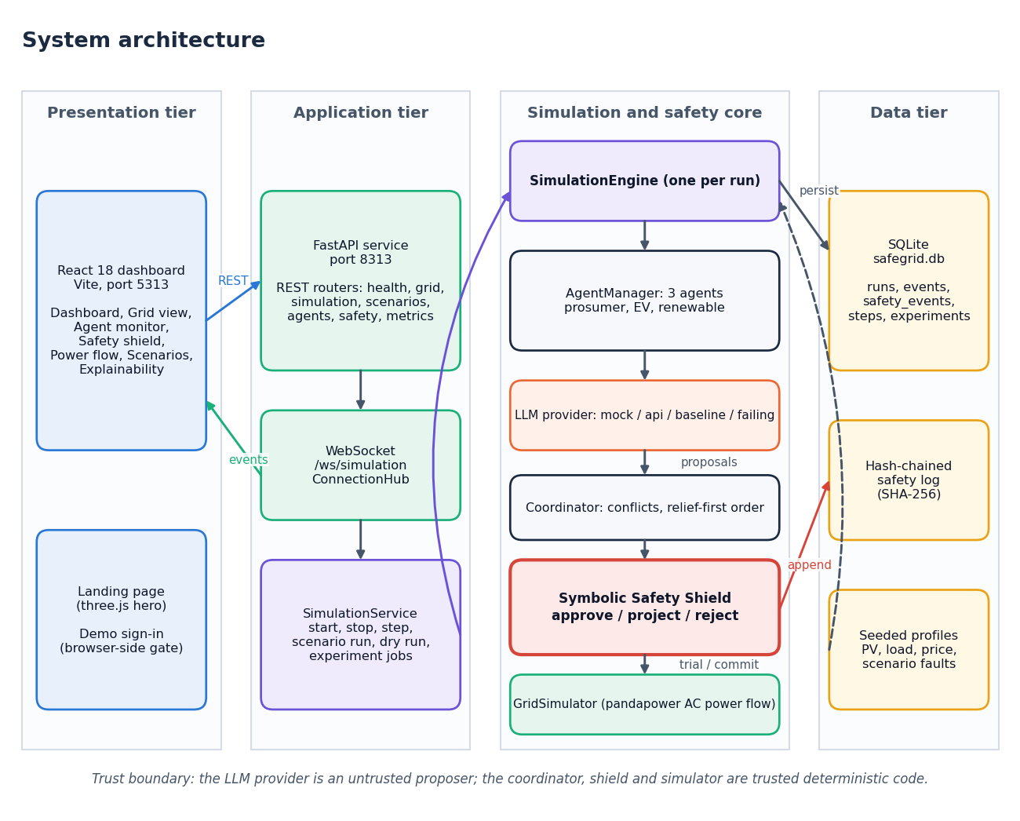
Figure 2: SafeGrid-AI places a deterministic shield between the agents and the grid (overview, detailed in Chapter 5)

CHAPTER 3: FEASIBILITY STUDY
Before building the system we asked four questions: can it be built with the tools at hand, what does it cost, will the intended users be able to operate it, and does it fit the project calendar. This chapter answers them with what actually happened during the project.

3.1 Technical Feasibility
Every component of SafeGrid-AI is free, mature, open-source software and runs on one ordinary desktop computer. The network is modelled and solved with pandapower [11]; the service layer is FastAPI with pydantic models and uvicorn; the dashboard is React 18 built with Vite, with three.js only on the landing page; persistence is SQLite from the Python standard library. The language-model side sits behind one small interface, so the project depends on no particular provider and was built and tested without an API key.
Feasibility was confirmed by measurement. The whole stack ran on a Intel Core i5-12500 (6 cores, 12 threads), 15.7 GB RAM, Windows 11 Pro, no GPU used. A read request such as the grid state returns in a median of 2.5 ms and a full simulation step, including three agent decisions and the shield's trial power flows, in a median of 440.7 ms, so a 32-step scenario completes in about ten seconds. The main technical risks and how they were handled are summarised below.
Table 4: Technical risks and mitigations
Risk | Mitigation in the project
A language model emits an unsafe or malformed action | The proposal is a schema-validated EnergyAction; the Symbolic Safety Shield validates it; a failure becomes a labelled, shielded deterministic fallback
No API key or no network during development and demonstration | A deterministic, seeded mock provider produces repeatable proposals, including deliberately unsafe ones
Power flow is slower than the control step | Trial power flows run in a worker thread; measured mean step time is 348 ms against a 15-minute simulated step
Results cannot be reproduced | All profiles and faults come from a seed; all 63 runs are recorded in one JSON file
Safety log could be altered after the fact | Each event carries the SHA-256 of the previous one; the chain was valid in 21 of 21 shielded runs

Two design choices keep the technical risk low. The service is asynchronous: the agents decide concurrently and the CPU-bound part of a step (the shield and the power flows) runs in a worker thread, so a slow step never blocks the WebSocket stream or the read endpoints. And the language-model provider is replaceable at run time, with four implementations: a seeded mock, an API-based provider (Anthropic or OpenAI wire format, with the returned tool call validated against the action schema), a rule-based provider and a provider that always fails, used to test the fallback. Because the shield does not depend on the provider, switching changes how good the proposals are, not whether the executed actions are safe.

3.2 Economic Feasibility
The project was built without any purchase. The development machine already existed, all software is open source, and the measured results use the mock provider, so no paid language-model service was used. The table below lists the resources and what each cost the project. It is an account of what was incurred, not a budget estimate for a deployment, and team effort is not priced.
Table 5: Development resources and cost incurred (INR)
Resource | Source | Cost incurred (INR) | Note
Development and test computer | Existing desktop PC | 0 | No purchase; Intel Core i5-12500 (6 cores, 12 threads), 15.7 GB RAM, Windows 11 Pro, no GPU used
Python libraries (pandapower, FastAPI, pydantic, numpy, pandas, scipy) | Open source | 0 | Installed from the public package index
Front-end libraries (React, Vite, three.js, charting) | Open source | 0 | Installed with npm
Database | SQLite, Python standard library | 0 | No server to run
Test and capture tools (pytest, Playwright, Chromium) | Open source | 0 | Used for tests and screenshots
Language-model API | Not used for measurements | 0 | A paid API would be needed to run the optional real-LLM provider; its cost depends on the provider and was not estimated
Hosting | Local machine only | 0 | No cloud deployment was made

A real deployment would be dominated by other costs: measurement and communication equipment, integration with the operator's systems, a live language-model service with its per-request cost and latency, and verification of the safety layer. We do not estimate them, because no such deployment is within the scope of this work.

3.3 Operational Feasibility
The intended user is a grid operator, a researcher or a student who wants to see how an AI controller behaves on a small network. The dashboard has a landing page, a sign-in page and seven working views (dashboard, grid, agents, safety shield, power flow, scenarios and explainability), with run controls, a scenario choice and an agent-brain choice in the top bar of every screen, and a demo sign-in for reviewers. The interface works at widths from 360 to 1440 pixels in light and dark themes, and a browser walk through every screen produced no console errors and no horizontal overflow. Starting the system takes one script on Windows (run.bat); Appendix B gives the manual steps.
Use by actual operators was not tested. No user study was carried out, so operational feasibility rests on the working software and the browser checks, not on user feedback.

3.4 Schedule Feasibility
The work followed the three review phases of the course. No calendar dates are given because the project record does not hold them.
Table 6: Project schedule by review phase
Phase | Planned content | Delivered
Review 1 | Problem identification, literature survey, objectives, proposed architecture | Batch abstract, base paper record, literature survey of five papers, objectives and problem statement
Review 2 | Design and core implementation: network, agents, shield, API | Pandapower network, three agents with provider interface, coordinator, Symbolic Safety Shield, FastAPI REST and WebSocket, SQLite store, first scenarios
Final review | Complete system, evaluation, user interface, documentation | Seven scenarios and three-strategy experiment (63 runs), React dashboard, tests, screenshots, this report, decks and paper

3.5 Advantages and Constraints

Advantages
• No cost, no special hardware, and no dependence on any single model provider.
• A repeatable experiment: the same seed gives the same profiles and the same mock decisions, so results can be regenerated.
• A modular design in which the provider, the agents, the shield and the simulator can each be replaced or tested alone.

Constraints
• The network is a three-node synthetic feeder, so the findings do not transfer to real networks without further work.
• Real-LLM behaviour and latency are unknown; the mock provider is the only one measured.
• The shield's guarantee is only as good as the network model and the configured limits.
• Two unit tests fail on numeric tolerances and one WebSocket test hangs (Chapter 7); none of these affects the experiment results, but they are open defects.

CHAPTER 4: SYSTEM REQUIREMENTS AND ANALYSIS

4.1 Existing System
Today a low-voltage feeder with distributed generation is operated by fixed rules: inverter settings that limit voltage rise, time-of-use tariffs that nudge consumers, and protection that trips when a limit is breached. The base paper's multi-agent system [1] is a better organised version of the same idea, with four rule-based agents that divide the control of a DC microgrid among themselves. Recent research systems add a language model that plans actions [2][3], but they are prototypes whose safety checks are performed by trial execution, and they give an operator no structured explanation of each decision.
An operator sees the outcome, not the reasoning: a voltage alarm, a tripped breaker, a monthly bill. There is no way to ask why a battery was charged at a particular time, and with a language-model controller the answer is usually generated text whose faithfulness to the real cause cannot be checked [17]. The needs that follow are for a controller that adapts, that is checked by something other than itself, and that leaves a record.

4.2 Limitations of the Existing System
• Fixed rules cannot adapt to renewable variability, price changes or a changed topology.
• A central controller is a single point of failure; local rules alone do not coordinate neighbouring nodes that share a feeder.
• An unconstrained AI agent can propose an unsafe action, and a check that is itself performed by a language-model agent depends on the model.
• Decisions are not accompanied by explanations that an operator can audit, and there is no tamper-evident record of what was proposed and what was executed.

4.3 Proposed System
SafeGrid-AI is a neuro-symbolic multi-agent controller. Each of three agents, for a household prosumer, an electric-vehicle charger and a renewable prosumer, perceives a structured context (its own load, solar output, battery state, the price, its neighbours' exchange and the grid limits) and asks a provider for one EnergyAction: charge or discharge the battery, import or export power, curtail generation, shift load, or stay idle. A coordinator detects conflicting proposals and orders them with relief actions first. The Symbolic Safety Shield then validates each proposal against the cumulative grid state and approves it, projects it to the largest safe value by bisection, or rejects it; only validated set-points are committed to the power-flow model. Each decision is explained, stored, streamed to the dashboard and, if not a plain approval, appended to the hash-chained safety log.
The three agents differ in what they own. The prosumer agent (node 1, a household with 6 kWp of solar and a 10 kWh battery) trades off its own load, the tariff and its battery. The EV agent (node 2, a 40 kWh vehicle battery that can only be charged, at up to 7.4 kW) decides when to charge. The renewable agent (node 3, 20 kWp of solar and a 30 kWh battery) decides how much to store, export or curtail. The tariff is an illustrative five-band time-of-use schedule of 3.8, 5.2, 4.6, 9.0 and 5.0 rupees per kWh, with exported energy credited at 60 % of the import price. Seven scenarios (normal, high solar, peak demand, battery stress, line congestion, voltage violation and unsafe AI action) stress different limits; the last injects deliberately unsafe and malformed proposals so that the shield's behaviour can be seen.
When a provider fails, times out or returns something that does not match the action schema, the agent substitutes a deterministic cost-aware fallback decision, labelled as such and shielded like any other. When two proposals conflict, the coordinator records the conflict and validates the relief actions first, so that a curtailment is evaluated before a competing charge request on the same feeder.
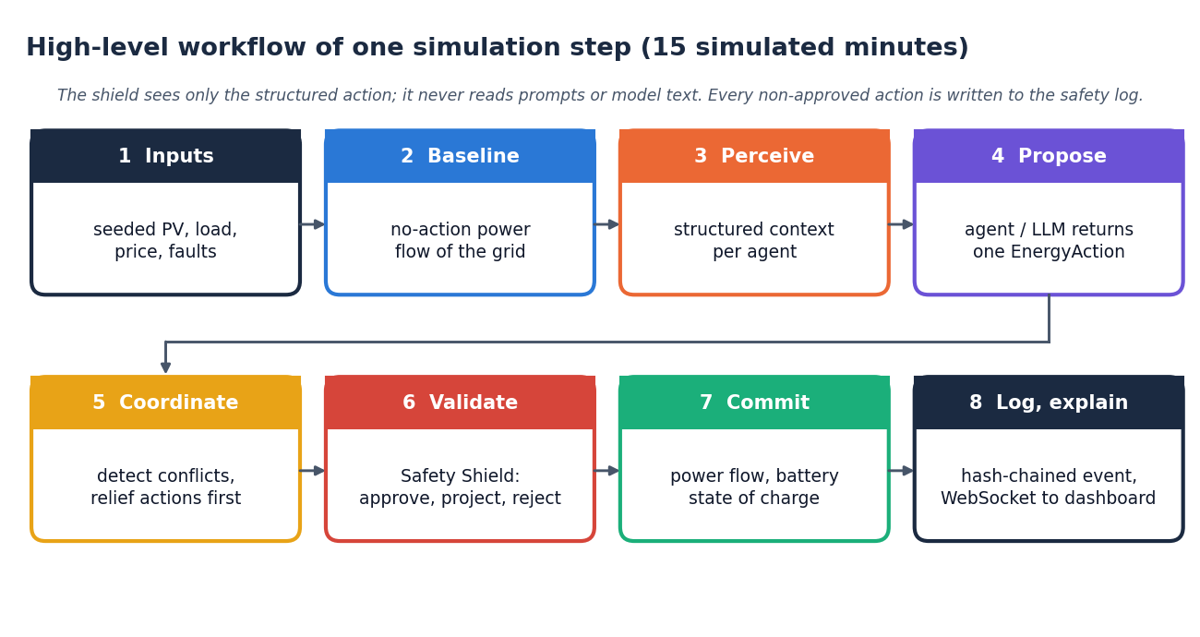
Figure 3: Workflow of one simulation step in the proposed system

4.4 Advantages of the Proposed System
• Safety independent of the model: executed actions caused no limit violation in any of 504 shielded steps, while the same agents without the shield did so in 99 steps.
• Intent preserved: 237 of 1,512 proposals were scaled down instead of being discarded, and only 113 were rejected.
• Explainable: every decision shows its inputs, factors, action and safety verdict, without any chain-of-thought text.
• Auditable: a hash-chained log whose chain was valid in 21 of 21 runs.
• Testable: seeded scenarios, an experiment runner, a dry-run endpoint that validates a hand-made action without applying it, and an automated test suite.

4.5 Functional Requirements
Table 7: Functional requirements
ID | Requirement | Where implemented
FR-1 | Configure a run: scenario, seed, provider, steps, constraint overrides, initial state of charge, shield on or off | RunConfig, POST /api/simulation/start|reset
FR-2 | Start, stop, reset and single-step a run, and report its status | SimulationService, /api/simulation/*
FR-3 | Generate seeded solar, load and price profiles and inject scenario faults | simulation/scenarios.py
FR-4 | Give each agent a structured context of its node, neighbours, price and limits | agents/base_agent.py (perceive)
FR-5 | Obtain one schema-validated EnergyAction per agent per step, with a labelled deterministic fallback on any provider failure | llm/*, agents/base_agent.py (decide)
FR-6 | Detect peer mismatch, target contention and shared-feeder conflicts and order proposals relief-first | simulation/coordinator.py
FR-7 | Validate every action with the Symbolic Safety Shield: approve, project or reject, with the violated checks | safety/shield.py
FR-8 | Commit only validated set-points and solve the AC power flow | grid/simulator.py
FR-9 | Record non-approved actions in a SHA-256 hash-chained log and verify the chain | safety/events.py, /api/safety/events
FR-10 | Build a structured explanation for every decision (inputs, factors, action, safety result) | agents/explain.py
FR-11 | Validate a custom action as a dry run without changing the grid | POST /api/agents/{id}/decision
FR-12 | Stream events to connected dashboards over a WebSocket | /ws/simulation, services/hub.py
FR-13 | Persist runs, steps, events and safety events and serve them back | database/store.py, /api/runs, /api/events
FR-14 | Run a scenario to completion and return its summary | POST /api/scenarios/{id}/run
FR-15 | Compare a rule baseline, agents without the shield and SafeGrid-AI over several seeds | simulation/experiment.py, /api/experiments
FR-16 | Show grid, agents, shield, power flow, scenarios and explanations in a responsive dashboard | frontend/src/pages/*

The sixteen requirements fall into four groups: FR-1 to FR-3 set up and drive a run; FR-4 to FR-8 are the decision pipeline of one step; FR-9 to FR-13 are the accountability functions (log, explanation, dry run, stream, persistence); FR-14 to FR-16 are evaluation and presentation. Each pipeline requirement maps to one module, so the shield can be tested without a model, the coordinator without a power flow, and the explanation builder without either.

4.6 Non-Functional Requirements
Table 8: Non-functional requirements and the evidence for each
Quality | Requirement | Evidence from this project
Safety | No executed action may create or worsen a limit violation (in the simulated model) | 0 violations caused in 504 shielded steps; 144 violations in 99 steps without the shield
Responsiveness | Read requests should feel immediate; a control step should be much shorter than the simulated step | Median 1.7 ms (health), 2.5 ms (grid state); step median 440.7 ms, p95 522.2 ms
Determinism | The same seed gives the same run | Seeded profiles, faults and mock decisions; results stored in one JSON file
Auditability | Interventions must be tamper-evident | Chain valid in 21 of 21 shielded runs; 354 safety events recorded
Reliability | A provider failure must not stop the run | Failing and malformed outputs become a labelled fallback (fallback rate 0.002)
Testability | Core logic is covered by automated tests | 52 of 55 tests pass; 2 fail on numeric tolerances, 1 hangs (Chapter 7)
Security | Model output is data, never code | The shield reads only EnergyAction fields; output is never run as code, SQL or shell; the API has no authentication (research prototype)
Usability | Works on phones and desktops, in light and dark themes | Browser walk at 360, 768 and 1440 px: no console errors, no horizontal overflow
Portability | Runs on one ordinary computer without a GPU | Measured on Intel Core i5-12500 (6 cores, 12 threads), 15.7 GB RAM, Windows 11 Pro, no GPU used

Two of these requirements pull against each other, and the trade-off is reported. Safety costs time and some renewable energy: the shield's trial power flows raise the mean step time from about 108 ms to 348 ms, and renewable utilisation is 0.86 instead of 1.00 for the rule baseline because the shield limits some solar output in the high-solar and voltage-violation scenarios. The agent-proposal dry run takes a median of 62.8 ms. These figures are for a mock provider; a real language model would add its own latency, which was not measured.

4.7 Hardware Requirements
No minimum configuration was determined by experiment; the table gives the machine on which every result in this report was measured, and we state it as the minimum we can vouch for. Smaller machines were not tried.
Table 9: Hardware requirements (measured machine)
Item | Specification
Processor | Intel Core i5-12500, 6 cores, 12 threads
Memory | 15.7 GB RAM
Accelerator | None; no GPU is used
Storage | Space for the repository, the Python environment and node modules (a few hundred megabytes); runs are stored in a local SQLite file
Display | Any screen; the dashboard is responsive from 360 pixels
Network | Local loopback only; internet is needed only to install packages or to call a real LLM

4.8 Software Requirements
Table 10: Software requirements (versions used)
Component | Version used | Role
Windows | 11 Pro | Operating system of the measurement machine
Python | 3.11.9 | Back end and scripts
pandapower | 3.5.6 | AC power-flow model of the feeder
FastAPI | 0.143.3 | REST and WebSocket service
pydantic | 2.14.1 | Schema validation of actions and configuration
numpy / pandas / scipy | 2.4.6 / 2.3.3 / 1.17.1 | Numerics used by pandapower and the profiles
uvicorn | 0.54.0 | ASGI server
httpx | 0.28.1 | HTTP client (API provider, tests)
pytest | 9.1.1 | Automated tests
SQLite | Python standard library | Persistence
Node.js | 24.19.0 | Front-end build and development server
React / Vite | 18 / 5 | Dashboard
three.js | bundled with the front end | Landing-page hero only
Playwright with Chromium | 1.44.0 | Browser walk-through and screenshots

4.9 User Roles and System Constraints
There is one role, the operator, who may run and inspect everything. The demo sign-in is a browser-side gate meant for demonstrations; the API has no accounts or authentication, so the system must not be exposed to an untrusted network. Cross-origin access is limited by a configurable list of allowed origins, and the environment file that holds any real API key is never committed to the repository.
The principal constraints are the following. The agents control only the three nodes of the simulated feeder. The limits enforced are 0.95 to 1.05 per unit for voltage (tighter than the plus or minus 10 % band that the European supply standard [19] allows at low voltage for most of the time), 100 % loading of lines and of the transformer, and 200 kW import or export at the connection to the external grid. Actions are limited to seven types with power between 0 and 1,000,000 kW as a sanity limit and a duration of 1 to 1,440 minutes, and reason codes must be upper-case identifiers of at most 48 characters. A proposal that breaks any of these structural rules is rejected before any power flow is run.

CHAPTER 5: SYSTEM DESIGN

5.1 Overall System Architecture
The design follows three rules. The model that proposes and the code that decides must be separate. Everything that decides must be deterministic and testable without a language model. And every decision must leave a record that can be checked afterwards. They follow the shielding idea of safe reinforcement learning [12], in which a verified layer sits between a learner and its environment, and the multi-agent view of power systems [8]. The layers are shown below.
Figure 4: System architecture of SafeGrid-AI
The system has four tiers. The presentation tier is the React 18 console served by Vite on port 5313: a landing page with a three.js hero, a demo sign-in, and seven console screens. The application tier is a FastAPI service on port 8313: REST routers, a WebSocket route (/ws/simulation) that streams events through the ConnectionHub, and SimulationService, which owns the current run, runs scenarios, answers dry-run requests and manages experiment jobs. The simulation and safety core holds one SimulationEngine per run. The engine drives an AgentManager with three agents, whose proposals come from an LLM provider (mock, api, baseline or failing); the coordinator orders the proposals; the Symbolic Safety Shield validates each one; and the GridSimulator runs the pandapower AC power flow for trial and committed states. The data tier is a SQLite file with five tables, the hash-chained safety log, and the seeded profiles and scenario faults. The footnote in the figure states the trust boundary: the LLM provider is an untrusted proposer; the coordinator, shield and simulator are trusted deterministic code.
Two properties of this layout matter. First, the shield package imports nothing from the language-model, agent, simulation or grid packages; a test (test_shield_does_not_import_llm_or_agents) checks this, so model text cannot influence the shield even by accident. Second, the API has no user accounts: it is a single-user research prototype, and the demo sign-in is only a browser gate.

5.2 High-Level Workflow
One control step has eight stages. (1) Seeded profiles give solar output, household load, price and any scenario fault. (2) A no-action power flow records the grid state if every agent stayed idle; it is the baseline against which later violations are attributed. (3) Each agent perceives a structured context built from its node, its neighbours and the grid limits. (4) Each agent returns one EnergyAction; a provider failure or invalid answer becomes a labelled deterministic fallback. (5) The coordinator detects conflicts and puts relief actions first. (6) The Safety Shield validates the proposals one after another against the cumulative grid state and approves, projects or rejects each. (7) Only the validated set-points are committed: the power flow is run again and battery states of charge are updated. (8) Non-approved decisions are appended to the hash-chained safety log, the step is stored, and events are streamed to the dashboard.
Figure 5: High-level workflow of one simulation step (15 simulated minutes)
The same stages run for Start (repeated on a timer, streaming events), Step (one pass) and a scenario run to completion. A dry run, POST /api/agents/{id}/decision, validates the agent's current proposal (or an action written by the operator) against the current state with trial power flows; nothing is committed and the run does not advance.

5.3 Data Flow Diagrams

Level 0: context
The context diagram shows SafeGrid-AI as a single process with two external entities. The operator sends the scenario, seed, provider choice, start, stop and step commands and dry-run actions, and receives live grid state, decisions, explanations, shield events and metrics. The optional LLM provider receives the structured context of each agent and returns a proposed EnergyAction. Internally the system writes the run store (runs, steps, events; D1) and the hash-chained safety log (D2), and reads the scenario and constraint configuration (D3).
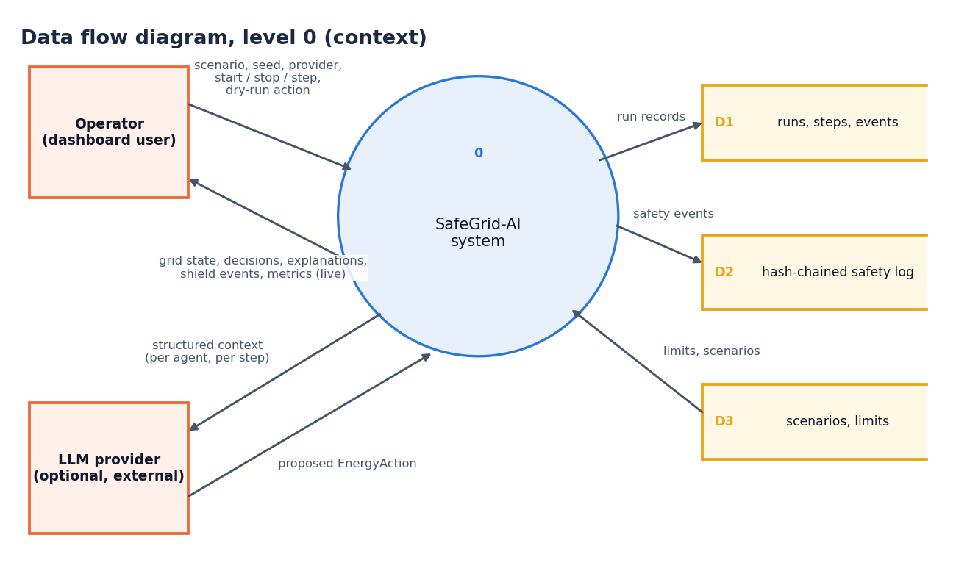
Figure 6: Data flow diagram, level 0 (context diagram)

Level 1
Level 1 splits the system into six processes. Configure and control run (1.0) accepts the operator's commands. Generate scenario inputs (2.0) combines the run configuration with the faults and limits in D3 and produces the seeded profiles. Agents perceive and propose (3.0) exchanges context and proposed actions with the LLM provider. Coordinate and validate (4.0) is the shield: it reads the limits, appends safety events to D2 and passes validated actions on. Execute (5.0) runs the power flow and updates battery states. Log, explain and publish (6.0) writes the run store (D1) and returns live state and explanations to the operator.
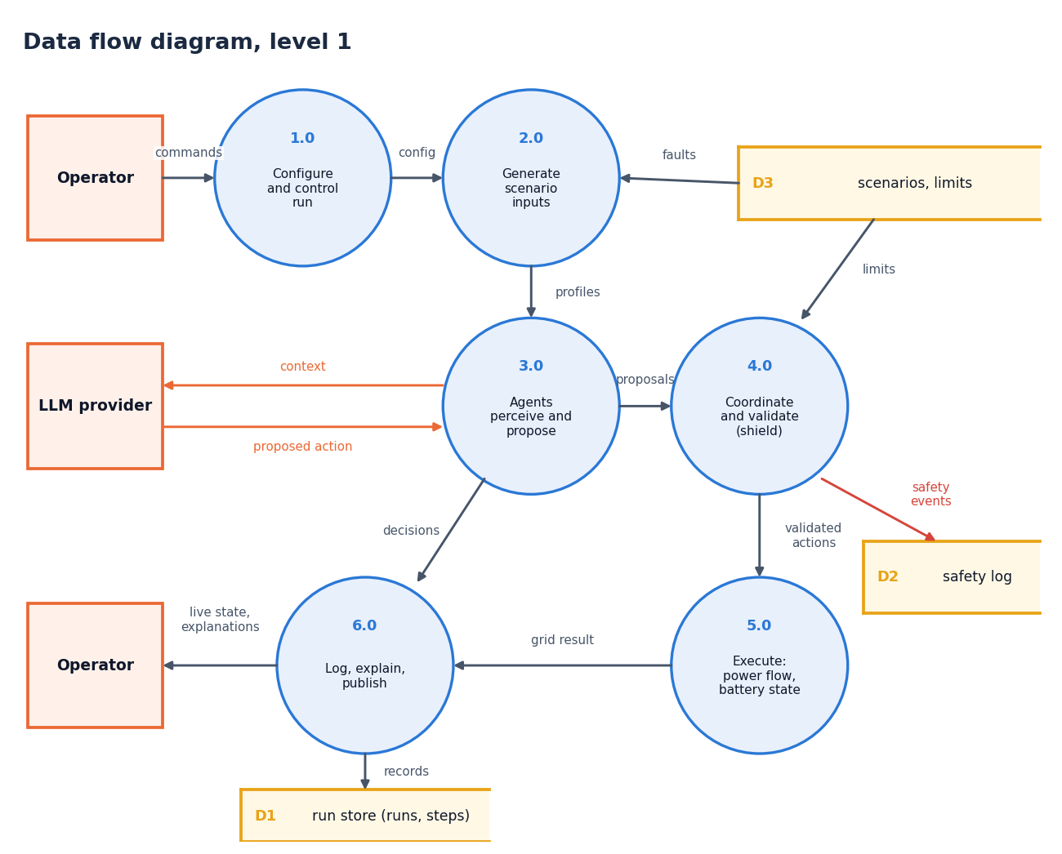
Figure 7: Data flow diagram, level 1

Level 2: the shield process
Level 2 expands the shield process into the steps that SymbolicSafetyShield.evaluate performs. Proposals are first ordered with relief actions first (4.1) and checked structurally (4.2). A trial power flow of the request as proposed (4.3) is compared with the no-action baseline so that only new or worse violations are kept (4.4); the limits come from D3. If there is none (4.5) the action is approved as requested. Otherwise a bisection finds the largest safe scale of the action (4.6), the rounded action is verified again (4.7), the decision is formed as approve, project or reject (4.8), and a hash-chained event is appended to D2 (4.9).
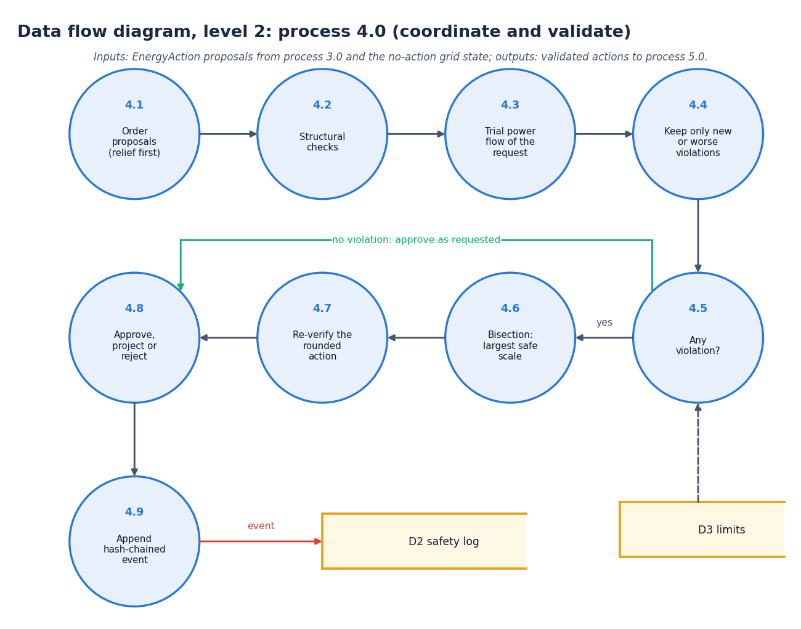
Figure 8: Data flow diagram, level 2: process 4.0 expanded

5.4 UML Diagrams

Class diagram
SimulationService creates and controls the SimulationEngine and uses the SQLiteStore. The engine owns the AgentManager, the GridSimulator and the SymbolicSafetyShield. The manager holds the agents derived from BaseAgent (the prosumer, storage and renewable subclasses differ only in the extra context they add); each agent has an abstract LLMProvider, implemented by the mock, api, rule-based, failing and fault-injecting providers, which returns an EnergyAction. The shield reads a ConstraintConfig, calls GridSimulator.trial and returns a ShieldDecision; non-approved decisions are logged as SafetyEvent records whose prev_hash and hash fields form the chain.
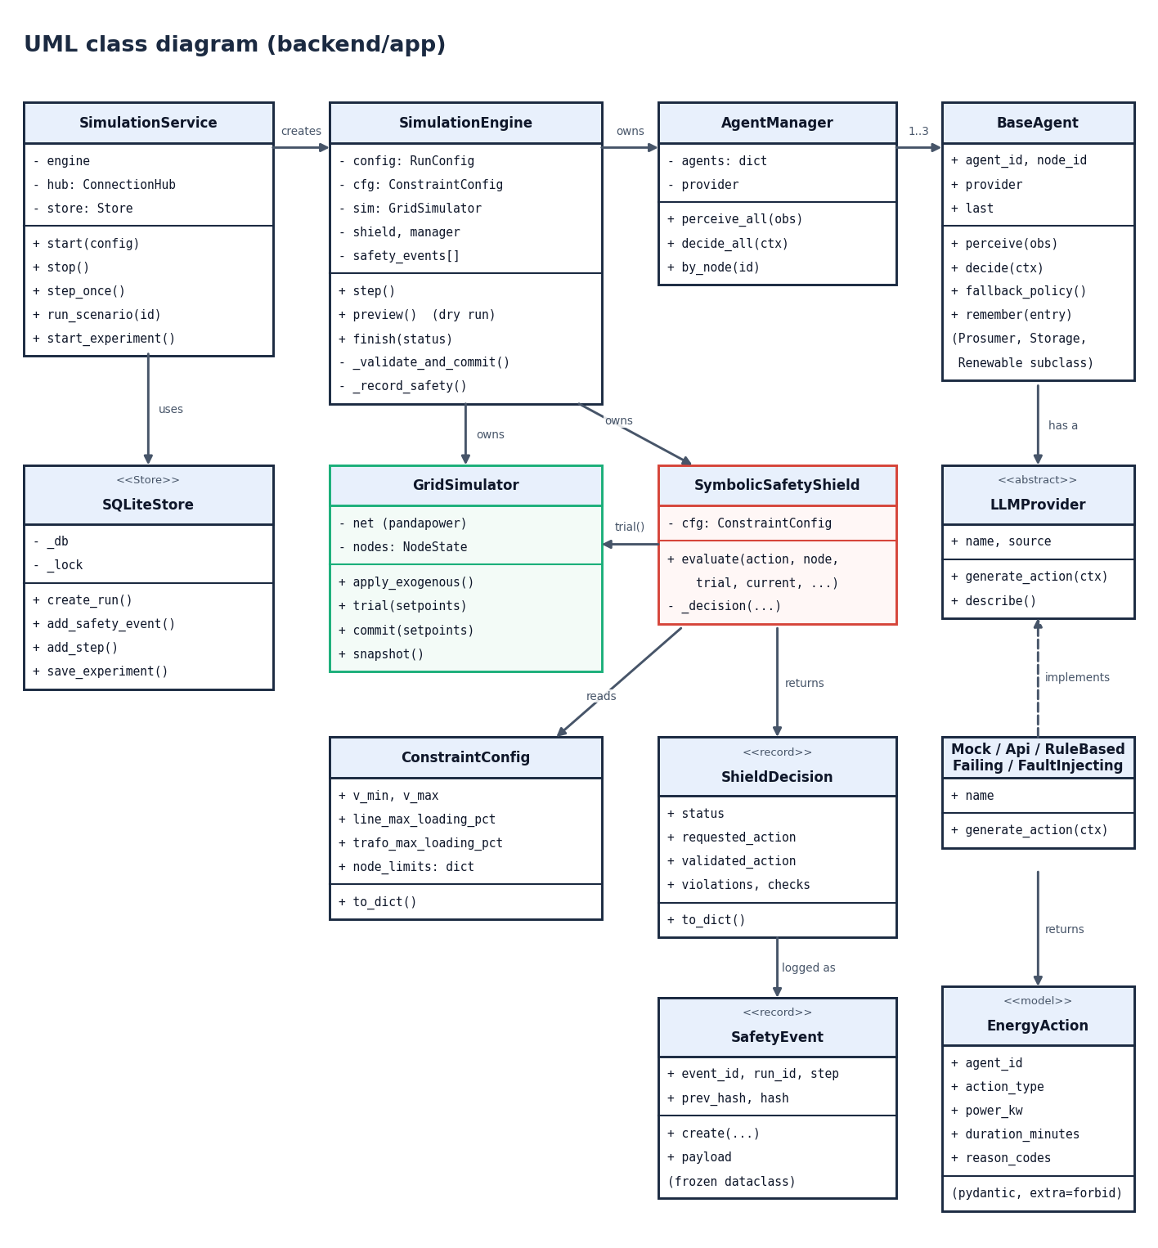
Figure 9: UML class diagram of the backend (backend/app)

Sequence diagram
The dashboard posts to /api/simulation/step (a live run repeats the sequence in a background task). FastAPI calls step() on the engine, which applies the exogenous inputs, runs the no-action power flow, and calls perceive_all and decide_all on the agents; they return three actions. The engine detects conflicts, orders the proposals and calls evaluate on the shield for each in turn (the dashed frame); the shield calls trial on the grid simulator several times and returns a ShieldDecision. The engine commits the validated set-points, stores the safety events and the step, publishes agent_action, safety_intervention and grid_update events to the WebSocket clients, and returns the step record.
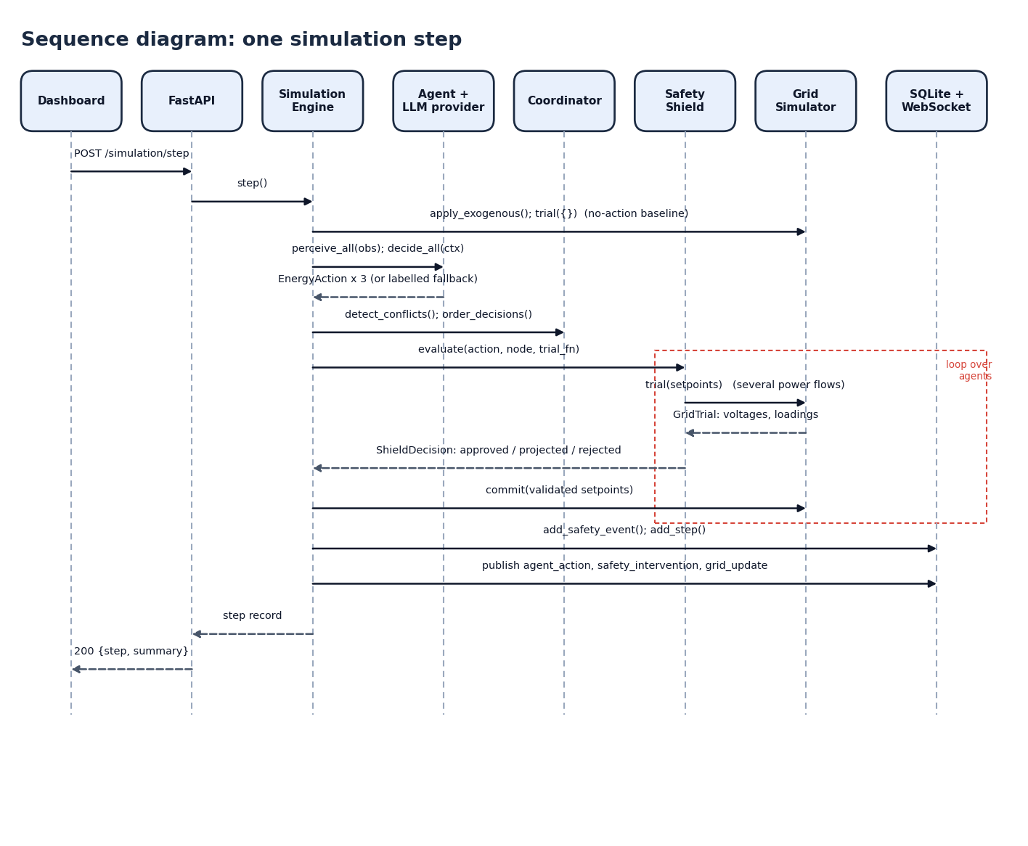
Figure 10: Sequence diagram: one simulation step

Use-case diagram
The operator can sign in with the demo account, choose a scenario, seed and agent brain, start, step, stop or reset a run, watch the grid, agents and shield live, inspect an agent decision and its explanation, dry-run a custom action against the shield, run a scenario to completion and compare strategies over several seeds. The optional LLM provider takes part in the run use cases by answering each agent's context; the experiment scheduler (a background job inside the service) takes part in the strategy comparison.
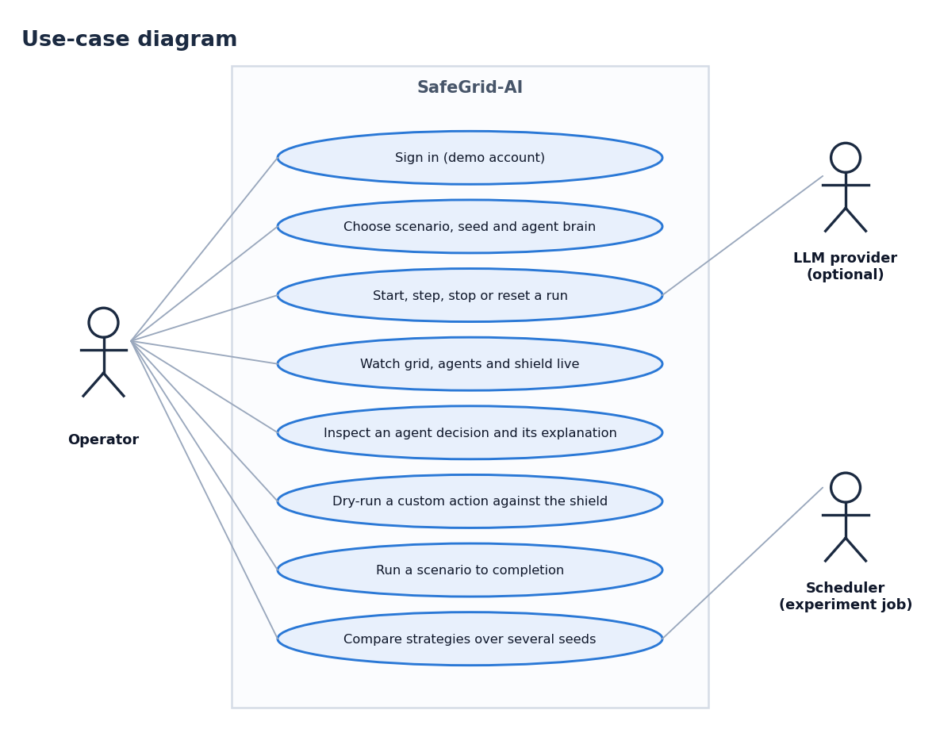
Figure 11: Use-case diagram

5.5 Entity-Relationship Diagram
runs holds one row per simulation run, with its configuration, resolved settings, summary and the final hash of the safety chain. events (stream events), safety_events (non-approved decisions with their hash chain) and steps (one row per step) each reference a run by run_id, one run to many rows. experiments is independent: it stores the specification and aggregate results of a strategy comparison. Two indexes speed up the lookups of events and safety events by run.
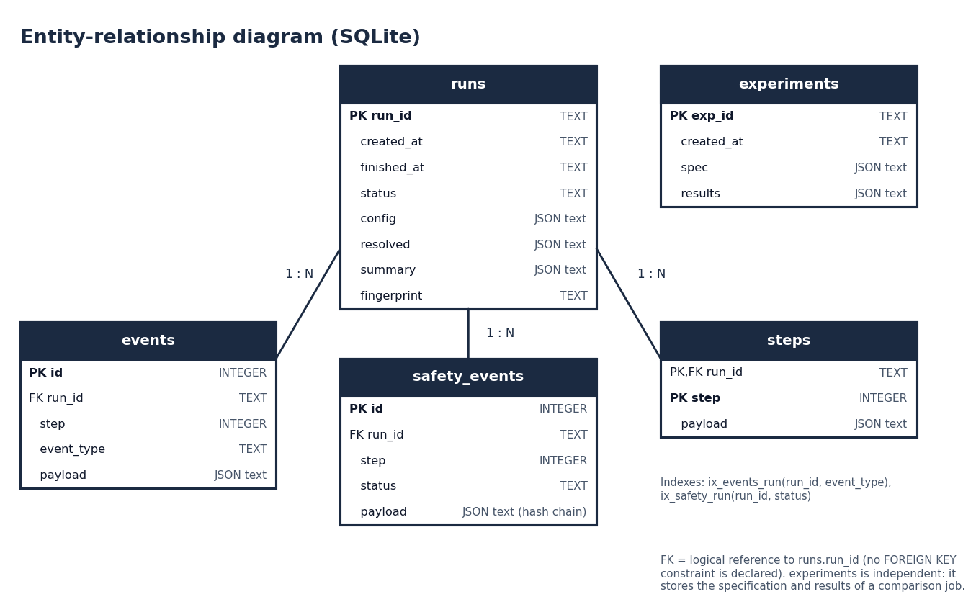
Figure 12: Entity-relationship diagram of the SQLite store

5.6 Database Schema and Table Descriptions
The store keeps five tables: run configuration and results, the event stream, the safety log, per-step records and strategy comparisons, which is everything the dashboard shows after a reload. Nothing else is persisted: the grid state is rebuilt from the seed and the scenario.
Table 11: Table runs
Column | Type | Constraint | Meaning
run_id | TEXT | PRIMARY KEY | Identifier of the run
created_at | TEXT |  | UTC creation time
finished_at | TEXT |  | UTC finish time (null while running)
status | TEXT |  | idle, running, paused, stopped, completed or failed
config | TEXT (JSON) |  | RunConfig as submitted
resolved | TEXT (JSON) |  | Scenario, steps, time step, seed, provider, constraints used
summary | TEXT (JSON) |  | Final metrics of the run
fingerprint | TEXT |  | Hash of the last safety event (chain head)

Table 12: Table events
Column | Type | Constraint | Meaning
id | INTEGER | PRIMARY KEY AUTOINCREMENT | Row number
run_id | TEXT | indexed with event_type | Run the event belongs to
step | INTEGER |  | Simulation step
event_type | TEXT |  | agent_action, safety_intervention, grid_update, ...
payload | TEXT (JSON) |  | The event as streamed

Table 13: Table safety_events
Column | Type | Constraint | Meaning
id | INTEGER | PRIMARY KEY AUTOINCREMENT | Row number
run_id | TEXT | indexed with status | Run the event belongs to
step | INTEGER |  | Simulation step
status | TEXT |  | projected, rejected (or approved for an anomaly record)
payload | TEXT (JSON) |  | Requested and validated action, violations, corrections, checks, grid before/after, prev_hash, hash

Table 14: Table steps
Column | Type | Constraint | Meaning
run_id | TEXT | PRIMARY KEY (with step) | Run
step | INTEGER | PRIMARY KEY (with run_id) | Simulation step
payload | TEXT (JSON) |  | Full step record: grid snapshot, agent rows, conflicts, counts

Table 15: Table experiments
Column | Type | Constraint | Meaning
exp_id | TEXT | PRIMARY KEY | Identifier of a strategy comparison
created_at | TEXT |  | UTC creation time
spec | TEXT (JSON) |  | Scenarios, seeds, steps, arms, time step
results | TEXT (JSON) |  | Per-run summaries and aggregates

The tables are created by CREATE TABLE IF NOT EXISTS, so a fresh checkout needs no migration, and every statement uses bound parameters. Structured values are stored as JSON text, which keeps the schema stable while the event payloads evolve. The store is a single connection with a lock, adequate for one operator and listed as a limit in Chapter 9.

5.7 Module Architecture
The backend is organised by responsibility. The table below lists the modules with their measured sizes (lines of Python, counted from the source files when this report is built). The backend has 3,117 lines in app/ and 624 lines of tests; the frontend has 6,989 lines of JavaScript, JSX and CSS.
Table 16: Backend modules and their size
Module | Role | Lines
api/, services/ | REST routers, run lifecycle, experiment jobs, WebSocket hub | 438
simulation/engine.py | One run: step loop, validation, metrics, events | 416
simulation/ (other) | Coordinator, scenarios, seeded profiles, strategy comparison, runners | 362
agents/, llm/ | Agents, manager, policies, explanations; provider contract and providers | 544
safety/ | Constraints, validator, projector, shield, hash-chained events | 621
grid/ | pandapower network, power-flow wrappers, GridSimulator | 400
database/, models/, config.py, main.py | SQLite store, EnergyAction and run schemas, settings, entry point | 336
Backend total |  | 3,117

The frontend is a single-page application with one lazy-loaded chunk per page (landing, login, dashboard, grid view, agent monitor, safety shield, power flow, scenarios, explainability), so three.js is fetched only for the landing page. State is kept in a SimulationProvider that wraps the REST and WebSocket clients; the pages are views of that state.

5.8 Shield Decision Workflow
The next three figures show the core algorithm, the grid it protects and the audit mechanism, the parts of the design that Chapter 8 tests directly.
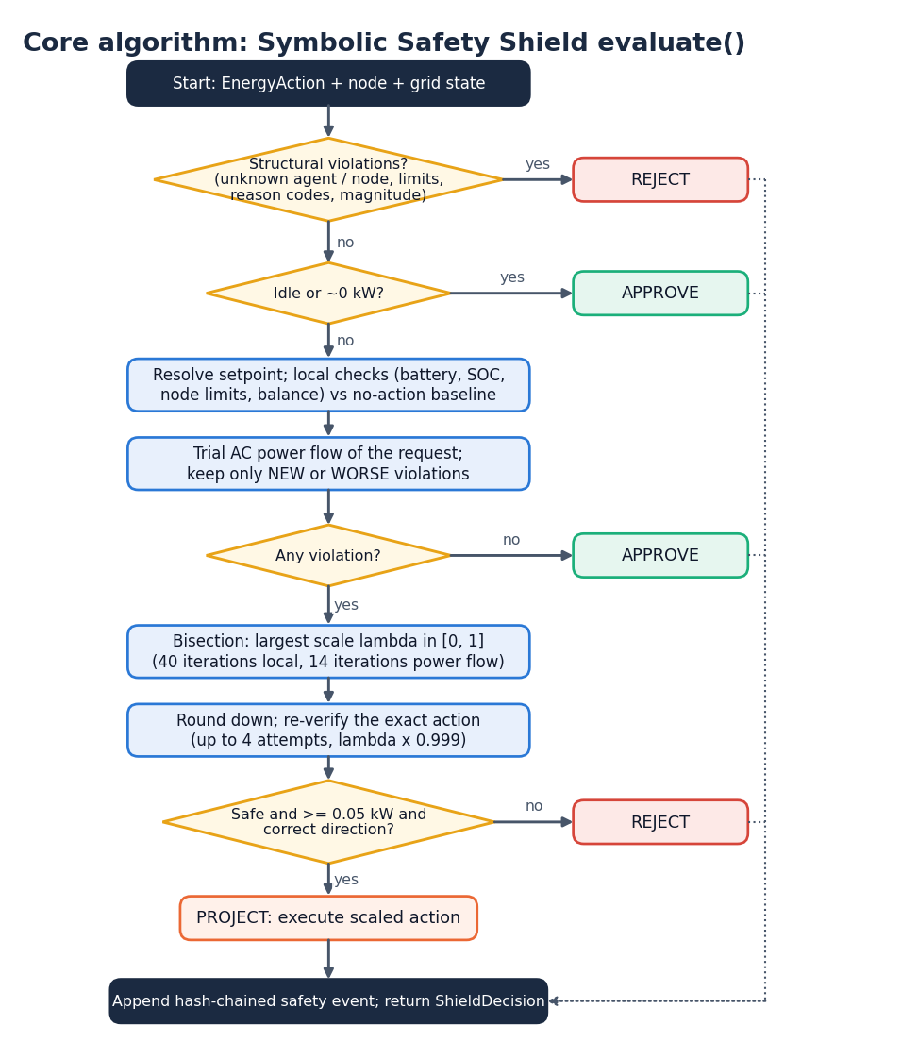
Figure 13: Core algorithm: Symbolic Safety Shield evaluate()
The flowchart follows the code in safety/shield.py. A structural violation (unknown agent or node, an agent acting on a node it does not own, a non-finite, negative or implausible power) rejects the action at once; an idle or zero-power action is approved. Otherwise the action becomes a physical set-point, the local checks (battery, state of charge, node limits, balance) and one trial power flow are run, and only violations that are new or worse than the no-action state count. With none, the action is approved. With some, a bisection (40 iterations for local limits, 14 for power-flow limits) finds the largest safe scale; the rounded action is re-verified up to four times; and the action is rejected if nothing safe remains, if the safe part is below 0.05 kW, or if an import or export target would change direction. Otherwise the scaled action is executed as a projection. Every outcome other than approval is appended to the safety log.
Figure 14: Simulated low-voltage feeder (pandapower network)
The simulated grid is a 20 kV external grid feeding a 0.25 MVA 20/0.4 kV transformer (T0) at bus B0. Line L0_1 (0.30 km) connects B0 to B1, where node_1, the residential prosumer (6 kWp PV, 10 kWh battery), is attached; line L1_3 (0.45 km) continues to B3, node_3, the renewable prosumer (20 kWp PV, 30 kWh battery); line L0_2 (0.25 km) connects B0 to B2, node_2, the EV (40 kWh battery, 7.4 kW, charge only). All lines are NAYY 4x50 SE cable and the load power factor is 0.95.
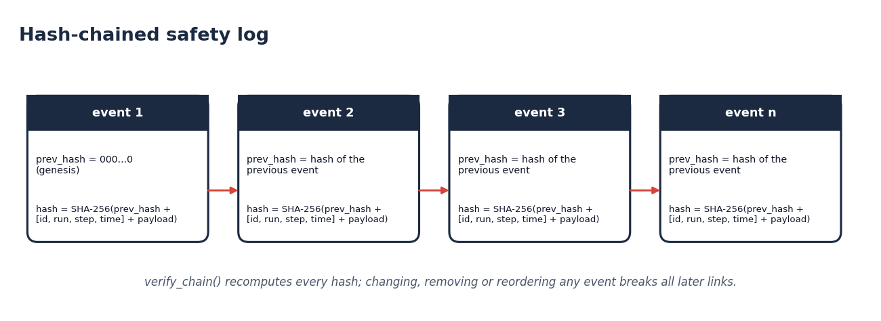
Figure 15: Hash-chained safety log
Each safety event stores the hash of the previous event (a string of zeros for the first) and its own SHA-256 hash over the previous hash, the identifiers [event id, run, step, simulated time] and the canonical payload. verify_chain recomputes every hash, so changing, removing or reordering any event breaks all later links. The wall-clock time is stored but excluded from the hash so that reruns are comparable.
Design limits. The feeder is small by choice: one step still costs several trial power flows, and the experiment of Chapter 8 needed about ten minutes for 63 runs. The shield checks actions against the model it is given; if the simulated network differs from a real one, the guarantee does not carry over. Grid-Agent [2] also validates plans by sandboxed execution, which likewise depends on the model that is executed. This limitation is stated again in Chapters 8 and 9.

CHAPTER 6: METHODOLOGY AND SOFTWARE IMPLEMENTATION

6.1 Overall Methodology
The method has four ingredients, each answering one sentence of the problem statement. A simulated grid supplies physics: a pandapower [11] AC power flow on a three-node low-voltage feeder with seeded solar, load and price profiles. Agents supply decisions: each node has an agent that perceives a structured context and proposes one action per step. A Symbolic Safety Shield supplies safety: it approves, projects or rejects every proposal before anything is executed. An audit and explanation layer supplies accountability: every decision carries a structured explanation and every intervention is appended to a hash-chained log.
The evaluation method is an ablation. The same seven scenarios and seeds are run under three controllers: a non-LLM rule baseline, the agents with their proposals executed as requested, and the full SafeGrid-AI system with the shield between the agents and the grid. Because scenario and seed are identical, any difference in outcome is due to the controller or the safety layer.
The architecture follows the safe-learning literature. Shielding places a verified component between a learning agent and its environment and lets it override unsafe actions [12]; projecting an action onto the set of safe actions is the idea of the safety layer of Dalal et al. [13]; and surveys organise methods by how they respect safety constraints [14]. SafeGrid-AI adds the language-model proposer, the operator-facing explanation and an audit trail, in the setting of the multi-agent power systems of [8] and the LLM-based grid control of Grid-Agent [2].
The engine computes the metrics at every step; their exact definitions matter for reading Chapter 8:
Table 17: Evaluation metrics as computed by the engine
Metric | Definition
Violations caused by actions | Limit violations in the executed state that are new, or worse, than in the grid state with every agent idle (the attribution rule of Section 6.5): what the shield is designed to prevent.
Steps with violations caused | Steps in which at least one such violation occurred.
Violations the raw proposals would cause | Counterfactual: violations of a power flow in which every raw proposal of the step is applied together.
Steps with pre-existing stress | Steps in which the grid violates a limit even with every agent idle.
Steps with any violation | Steps in which the executed state violates any limit, whatever the cause.
Voltage violation steps, line overload events | Steps with a bus outside 0.95-1.05 pu; line-steps above 100 % loading.
Energy cost | Import energy times price minus export energy times 60 % of the price, summed over the run (INR, illustrative tariff).
Renewable utilisation | 1 minus curtailed energy over available PV energy; n/a when there is no PV (line_congestion runs at 18:00, after sunset).
Battery utilisation | Charged plus discharged energy over the total battery capacity of the three nodes (80 kWh).
Intervention rate | (Projected + rejected proposals) over all proposals.
Fallback rate, decision latency | Share of decisions made by the fallback policy; mean time the provider took to answer.
Step time | Wall-clock time of one engine step (agents, shield, trial power flows, commit).

6.2 Simulated Data and Scenarios
There is no external dataset in this project. The inputs of every run are generated from a seed, so any run can be reproduced exactly. No trained model exists, so no accuracy, precision, recall or F1-score is reported anywhere in this report.
For a time of day h in hours, solar output at a node is its peak power times a daily shape and a seeded cloud factor, load is its base load times a household shape with 5 % seeded noise, and price follows a time-of-use tariff:
sun(h) = sin(π (h − 6) / 12)^1.2 for 6 ≤ h ≤ 18, otherwise 0; PV(h) = kWp · pv_scale · sun(h) · cloud (1)
shape(h) = 0.55 + 0.35 · exp(−((h − 7.5) / 1.5)²) + 0.75 · exp(−((h − 19.5) / 2)²); load(h) = base · load_scale · shape(h) · (1 + 0.05 ε) (2)
The cloud factor is 0.88 plus 0.12 times a normalised five-point moving average of seeded Gaussian noise, clipped to 0.45-1.0. The tariff is 3.8 INR/kWh before 06:00, 5.2 until 10:00, 4.6 until 17:00, 9.0 until 22:00 and 5.0 afterwards; it is illustrative, not taken from a utility. Exported energy is credited at 60 % of the price of the same step. The time step is 15 simulated minutes.
Seven scenarios were defined. A scenario fixes the start time, length, scale factors for load, solar and price, the initial states of charge, the weakness of the grid, and a list of faults: intentionally unsafe or malformed proposals that replace an agent's answer for a range of steps. Faults apply to the two agent arms only, because the rule baseline has no model that could misbehave.
Table 18: The seven scenarios
Scenario | Start | Steps | Settings | What it exercises
normal | 09:00 | 32 | - | Balanced day; the mock provider occasionally oversizes a request (unsafe rate 0.15)
high_solar | 10:00 | 24 | load x 0.6, PV x 1.5; start SOC 0.35 / 0.30 | Surplus PV must be stored, exported or curtailed (unsafe rate 0.25)
peak_demand | 17:30 | 24 | load x 2.0, price x 1.2; start SOC 0.70 / 0.35 / 0.70 | Evening peak with heavy household and EV demand (unsafe rate 0.25)
battery_stress | 11:00 | 16 | start SOC 0.93 (node_1) and 0.13 (node_3) | Three injected faults: charge 12 kW, discharge 30 kW, discharge 8 kW beyond battery limits
line_congestion | 18:00 | 16 | line L0_2 limited to 0.009 kA; EV start SOC 0.30 | Injected fault: rated 7.4 kW EV charging in steps 1-8 overloads the weak feeder
voltage_violation | 10:00 | 16 | PV x 0.5, lines x 2.0 long, upstream 1.02 pu | Two injected faults: battery discharge (10 kW and 5 kW) at the feeder end pushes voltage up
unsafe_ai_action | 12:00 | 12 | - | Five injected faults: export 1000 kW, import 900 kW, discharge 50 kW, curtail 100 kW and one malformed output

Note on run length. The strategy comparison of Chapter 8 ran every scenario for 24 steps (6 simulated hours), longer than the native length of the four shortest scenarios. Their injected faults all lie in the first steps and are included; the later steps are ordinary operation under the same scale factors.

6.3 Perception: Building the Agent Context
Each step, every agent receives a structured JSON context built by BaseAgent.perceive: the identifiers, step and time, the node's load and solar power, the battery (availability, capacity, state of charge, ratings, state-of-charge window), the price and its daily statistics, a weather summary, the net exchange, state of charge and voltage of the neighbouring nodes, the grid constraints (voltage band, loading limit, node import and export limits, local voltage, worst line and transformer loading), and the agent's own previous action and its result. The EV agent adds the vehicle's connection state, required and critical state of charge, and whether vehicle-to-grid is enabled.
The context contains numbers and fixed labels only, and the system prompt of the API provider tells the model to treat every value as data, never as an instruction. The no-action power flow is computed before the agents are asked, so all agents see the same starting state.

6.4 Algorithm Selection and Justification
Why a proposer and a separate deterministic shield. A language model can read a rich context and propose a sensible action, but its output is probabilistic and can be wrong in ways that are costly on a physical network; ReAct-style agents interleave reasoning and acting without any guarantee about the acting [16], and the safety literature lists unsafe exploration and distributional shift as separate problems [15]. A deterministic checker after the proposer makes the safety property independent of the proposer and testable: the shield can be run with thousands of random or hostile actions without a model.
Why projection instead of rejection only. Rejecting every unsafe request wastes the useful part of a request that is only too large. The shield therefore executes the largest safe scale of the action: if a request of 4 kW exceeds the safe 2 kW (a hypothetical case), 2 kW is executed. The mock provider's oversized requests are of this kind.
Why bisection. Scaling an action by λ in [0, 1] moves its effect from none to the full request. For the limits considered, the safe region in λ is an interval that contains 0, because the no-action state is the reference. Bisection finds its boundary with a fixed number of evaluations and needs no gradients of the power flow: at most 40 cheap local evaluations, 14 power-flow evaluations and four re-verifications.
Why sequential, cumulative validation. Three agents may each propose something safe alone and unsafe together, such as two prosumers on the same feeder exporting at once. The shield therefore validates proposals one by one, each seeing the set-points already accepted in the step. The coordinator puts actions that can only help (idle, curtail, shift load) first and rotates the rest with the step number.
Why attribution to the action. If the shield rejected whatever coexists with a violation, a grid already outside its limits with every agent idle would make every action look unsafe. The shield instead blames an action only for violations that are new or that it makes worse than the no-action state, which keeps agents useful during stress and states exactly what the guarantee is.
Why a hash chain. Safety events are the evidence that the shield acted. A SHA-256 chain over the events, as specified in FIPS 180-4 [20], makes tampering detectable without any external service; it is a cheap integrity check, not a replacement for access control.
Why a mock provider. Experiments must be reproducible and free of cost and network dependence. The mock provider is deterministic for a given seed, agent and step; it is not a language model, and the report says so wherever results are given.

6.5 Mathematical Formulation
Let V_b be the voltage magnitude (per unit) at low-voltage bus b, I_l and I_l^max the current and rated current of line l, and T the transformer loading. The grid constraints applied to every candidate state are:
0.95 ≤ V_b ≤ 1.05 for every bus b; 100 · I_l / I_l^max ≤ 100 for every line l; T ≤ 100 %; −200 kW ≤ P_ext ≤ 200 kW (3)
The voltage band is narrower than the ±10 % band that EN 50160 [19] allows for public low-voltage supply, so a violation of the shield's limit is an early warning, not an incident. All limits are configuration values.
For a node with battery capacity C, charge and discharge efficiencies η_c and η_d (both 0.95), state of charge s, window [s_min, s_max] and time step Δt (hours), the largest battery power inside the window, and the state update on commit, are:
P_charge ≤ min( P_charge^max , (s_max − s) · C / (Δt · η_c) ); P_discharge ≤ min( P_discharge^max , (s − s_min) · C · η_d / Δt ) (4)
s' = s + P · Δt · η_c / C (charging, P > 0); s' = s + P · Δt / (η_d · C) (discharging, P < 0) (5)
The physical effect of an action on a node is a set-point (storage power S, curtailment c, shifted load d). Import and export actions are targets for the node's net exchange E; with the neutral exchange E0 = load − PV, the storage covers the difference:
E = (load − d) + S − (PV − c); import target P: S = P − E0; export target P: S = −P − E0 (6)
The node limits are E ≤ import limit and −E ≤ export limit. After each power flow the shield also checks that the network's power balance closes:
r = P_ext + P_gen − P_load − P_stor − P_loss; |r| ≤ 0.05 kW (7)
Projection. For a request with set-point s the shield looks for the largest scale factor that is safe:
λ* = max { λ ∈ [0, 1] : safe(λ · s) }, safe(x) = no new or worse violation when x is applied (8)
If safe(s) holds, λ* = 1 and the action is approved. Otherwise bisection is used: with lo = 0 and hi = 1, the midpoint replaces lo when it is safe and hi otherwise; 40 halvings are used for the local limits (resolution 2^−40) and 14 for power-flow limits (about 6 × 10^−5). For import and export actions the power after projection is |E0 + λ (E_req − E0)|, so the scaling moves the node's exchange between its neutral value and the request. The scaled power is rounded down to six places and checked again, up to four times with λ reduced by 0.1 % each time, so the executed action is exactly the verified action. A projection below 0.05 kW, or one that would turn an import into an export or the reverse, is rejected.
Attribution. Let V(x) be the set of violations of a state x and ex(v) the excess of a violation v beyond its limit. For the state after an action a and the no-action state 0, the violations blamed on the action are:
V_caused(a) = { v ∈ V(after a) : v ∉ V(0) or ex(v) > ex_0(v) + 10^−4 } (9)
Audit chain. With h_0 a string of 64 zeros and for the i-th event with identifier id, run r, step k, simulated time t and canonical JSON payload p:
h_i = SHA-256( h_{i−1} ‖ canon([id_i, r, k, t_i]) ‖ canon(p_i) ) (10)

6.6 Agents, Providers and Fallback
Three agents control the three nodes: prosumer_01 (residential prosumer, node_1, 6 kWp, 10 kWh), ev_01 (EV and storage, node_2, 40 kWh, 7.4 kW, charge only by default) and renewable_01 (renewable prosumer, node_3, 20 kWp, 30 kWh). They share the BaseAgent class; the subclasses differ only in the extra context they add. A proposal is an EnergyAction: one of seven action types (charge, discharge, import, export, curtail, shift load, idle), a power in kW, a duration, an optional target node, up to eight reason codes and a confidence.
The action schema is strict: unknown fields are forbidden; power must be finite and between 0 and 1,000,000 kW; the duration lies between 1 and 1,440 minutes; reason codes must match [A-Z0-9_]{1,48}. An answer that fails the schema becomes a provider error and never reaches the shield as an action.
Table 19: LLM providers
Provider | Behaviour | Used for
mock | Deterministic stand-in for a language model: the transparent cost-aware policy plus seeded imperfections (oversized or full-rating requests) | All measured results
api | HTTP tool-calling provider (Anthropic or OpenAI wire format); the answer must be one propose_energy_action call that validates against EnergyAction | Implemented, not run live
baseline | Non-LLM time-of-use rules that ignore solar surplus and grid stress | Rule baseline arm
failing | Always raises an unavailability error to exercise the fallback path | Tests
fault-injecting wrapper | Replaces chosen agent/step proposals with unsafe or malformed ones (scenario faults) | Agent arms

Fallback. BaseAgent.decide waits for the provider with a timeout (20 s by default). If the provider is unavailable, times out, or returns an invalid answer, the agent uses the deterministic cost-aware policy and labels the decision fallback with the reason; it is shielded like any other. In the experiment, the fallback rate was 0.2 % of decisions, all from the injected malformed output at step 6 of the unsafe_ai_action scenario.
The deterministic policy. The cost-aware policy is a transparent set of rules, not an optimiser, and no optimality is claimed: it absorbs surplus solar into the battery, curtails when the voltage is high and the battery is full, discharges to support the grid or at high prices, charges the EV towards its target when the price allows, and otherwise idles. It underlies the mock provider and the fallback. The rule baseline is simpler and ignores solar and grid state.

6.7 Symbolic Safety Shield and Projection
SymbolicSafetyShield.evaluate receives one EnergyAction, a read-only view of the node, a function that runs a trial power flow for a candidate set-point (including the set-points already accepted in the step), and the current grid state. Its ten checks run in a fixed order, grouped by the violation codes they can raise; the dashboard shows the same ten names.
Table 20: The ten shield checks (25 violation codes)
# | Check | Codes | What it tests
1 | STRUCTURE | 7 | Unknown or mismatched agent, node or target; non-finite or negative power; invalid node state; malformed type
2 | POWER_LIMITS | 1 | Power larger than 5 times the node's reference power is implausible
3 | BATTERY | 4 | Battery missing or unavailable; charge or discharge rating; state-of-charge window
4 | NODE_LIMITS | 3 | Node import limit, node export limit, shiftable share of load
5 | POWER_BALANCE | 3 | Curtailment above generation; unreachable import/export direction; balance residual above 0.05 kW
6 | POWER_FLOW | 1 | The AC power flow must converge
7 | VOLTAGE | 2 | Every low-voltage bus within 0.95-1.05 pu
8 | LINE_LOADING | 1 | Every line at or below 100 % of its rated current
9 | TRANSFORMER | 1 | Transformer at or below 100 % loading
10 | GRID_LIMITS | 2 | Import and export at the external grid at or below 200 kW

The procedure is: (1) structural checks; a violation rejects the action. (2) An idle or about-zero action is approved and recorded. (3) The action is converted to a set-point; the local checks and, if they pass, a trial power flow are run; only new or worse violations count. (4) With none, the action is approved, with its duration aligned to the time step if necessary. (5) Otherwise the largest safe scale is found by bisection, first for the local limits and then for the power-flow limits, and the rounded action is re-verified. (6) The action is rejected if nothing safe remains, if the safe part is under 0.05 kW, or if the direction of an import or export target cannot be kept. (7) Otherwise the scaled action is returned as PROJECTED with the corrections made (requested and executed power, and the violation codes that caused the scaling).
The returned ShieldDecision keeps the original request, the validated action, every violation with its code, component, requested and allowed values, the corrections, the result of each of the ten checks (passed, failed, or not evaluated because an earlier check rejected the action), and the grid summary before and after. The original request is never overwritten, so the audit trail always shows what the agent asked for.
Failures are conservative: a power flow that does not converge raises POWER_FLOW_FAILED and the action is rejected. The shield module imports nothing from the model, agent, simulation or grid packages and receives only the structured fields of the action.

6.8 Coordinator
The coordinator never edits an action. It detects three kinds of conflict and fixes the validation order. PEER_MISMATCH is raised when some agents propose to export while others propose to import and the totals differ by more than 0.5 kW; the residual goes to the external grid. TARGET_CONTENTION is raised when several proposals name the same target node. SHARED_FEEDER is raised when node_1 and node_3, whose feeder shares line L0_1, both push power the same way by more than 0.5 kW. Conflicts are published as events and counted: 241 were detected in the 21 shielded runs. The order puts relief actions first and rotates the rest by step.

6.9 Explanations
Every decision has a structured explanation, built from the context and the decision, not generated by a model: the decision and a readable label, the power, the reason codes in plain sentences, the confidence, the values the agent saw (solar, load, state of charge, price, local voltage, worst line loading), the decision source (mock, llm, baseline, fallback, injected) and, once the shield has answered, the safety result, the violations and the executed power.
No chain-of-thought is requested or stored. The batch abstract speaks of explainable reasoning; the implementation deliberately shows inputs, decision factors, the action and the safety result instead of free-text reasoning. A model's stated reasoning is not always a faithful account of why it answered as it did [17], whereas the inputs and the shield's checks can be verified. A test (test_explanation_is_structured_and_has_no_chain_of_thought) checks that the explanation has no chain-of-thought or reasoning field.

6.10 Application Architecture and Implementation
Backend. The backend is a FastAPI application (app/main.py) with five routers and one WebSocket route. SimulationService owns the current SimulationEngine and the background task that runs it, and implements start, stop, reset, single step, scenario run and the background experiment jobs, which are stored when they finish. The engine's step is asynchronous: the agents are asked concurrently, and the CPU-bound part (shield, trial power flows and commit) runs in a worker thread so that the API stays responsive. The GridSimulator guards the shared pandapower network with a re-entrant lock because API dry runs may arrive during a run. The ConnectionHub broadcasts events to the browsers and drops a client whose send fails, so a broken client can never stop the simulation.
Persistence. SQLiteStore writes runs, stream events, safety events, per-step records and experiments (Chapter 5). The head of each run's hash chain is stored as the run's fingerprint, so a stored run can be checked later.
Frontend. The console is a React 18 application built with Vite, in the kit named "Depth Studio"; the three.js hero of the landing page is replaced by a static image for users who prefer reduced motion. A SimulationProvider keeps the REST and WebSocket state; the run bar on every screen selects the scenario, agent brain, seed and playback speed and offers Start, Resume, Step, Stop and Reset. The charts are drawn with Recharts and the layout adapts from 360 to 1440 pixels, with the sidebar becoming a drawer on narrow screens.

6.11 API Design
The REST API is described by FastAPI's OpenAPI page at /docs. Requests and responses are validated with Pydantic models (RunConfig, DecisionRequest, ExperimentRequest, EnergyAction). Errors use standard codes: 404 for an unknown scenario, agent or run, 409 when the run is in the wrong state, 422 for an invalid body.
Table 21: API endpoints
Method | Path | Purpose
GET | /api/health | Service, provider and pandapower status
GET | /api/grid/state, /api/grid/topology | Current grid snapshot; nodes, edges and devices for the diagram
POST | /api/simulation/start?resume=, /stop, /reset, /step | Run control (409 if already running or finished)
GET | /api/simulation/status | Status, step, provider
GET | /api/scenarios | The seven scenario definitions
POST | /api/scenarios/{id}/run | Run a scenario to completion and return its summary
GET | /api/agents, /api/agents/{id} | Agent cards; one agent's history and latest decision
POST | /api/agents/{id}/decision | Dry run: validate the agent's proposal or an operator-written action; nothing is applied
GET | /api/events | Stream events of the run, filterable by type
GET | /api/safety/events, /api/safety/constraints | Hash-chained events with chain validity; active limits
GET | /api/metrics, /api/runs (+ /{id}, /{id}/steps) | Summary and per-step series; stored runs
POST / GET | /api/experiments/run, /api/experiments, /api/experiments/{id} | Strategy comparison jobs and stored results
WebSocket | /ws/simulation | Event frames: connected, simulation_started, agent_action, safety_intervention, conflict_detected, grid_update, simulation_complete, simulation_stopped, simulation_error

RunConfig carries everything needed to reproduce a run: scenario, seed, steps, time step, provider, unsafe rate, playback delay, constraint overrides, initial states of charge, agent options, whether faults are injected, and whether the shield is enabled. The last field exists for the unshielded ablation arm of the experiment.

6.12 Security, Privacy and Error Handling
• Untrusted model output. The model answers only through one tool call whose arguments must validate against EnergyAction; the agent identity is set by the system; nothing from the model is executed, evaluated, or used as SQL, a shell command or a file path.
• Allow-list and bounds. Only seven action types are accepted; numbers must be finite and bounded; reason codes match a fixed pattern; unknown fields are rejected.
• Database. All statements use bound parameters; JSON is stored as text.
• Secrets. The API key and model name come from environment variables or an untracked .env file; no secret is in the code or in a commit; /api/health reports only whether an LLM is configured.
• Network. Allowed browser origins are configurable (CORS_ORIGINS); credentials are not sent; the development server proxies /api and /ws.
• Failure handling. Provider failure becomes a labelled fallback; a non-converging power flow rejects the action; WebSocket errors are isolated per client; a failed experiment job records its error.
• Privacy. The system handles no personal data: all inputs are synthetic.
What is not secured. The API has no authentication or rate limiting, and the SQLite store has no access control. The system is a single-user research prototype and must not be exposed to an untrusted network as it is.

CHAPTER 7: SYSTEM TESTING

7.1 Testing Strategy
SafeGrid-AI has two kinds of risk: ordinary software risk (a wrong response shape, a screen that fails on a narrow window) and a risk specific to the project, that a proposal which should have been stopped reaches the grid or that the audit record cannot be trusted. The strategy has four layers, and the second carries the most weight.
1. Unit tests (pytest) check each backend module in isolation, above all the shield, with hand-built nodes and limits so that the expected outcome can be written down in advance.
2. Scenario tests run the whole engine through the seven scenarios and assert the property the project exists to deliver: executed actions never create or worsen a violation.
3. Integration and smoke tests exercise the HTTP and WebSocket interface of a running server (scripts/smoke_test.py, 20 checks).
4. Browser walk-through drives every screen of the React console in Chromium with Playwright at three widths and in both themes, watching the console for errors.
The measured outcome (2026-10-18) is 52 of 55 test functions passing, 2 failing and 1 hanging. The failures and the hang are described in Section 7.2: they are defects of the test code, not of the shield, but they are defects. The environments were Python 3.11.9 (pytest 9.1.1, pandapower 3.5.6, FastAPI 0.143.3, pydantic 2.14.1) and Chromium driven by Playwright 1.44.0.

7.2 Unit Testing
The backend has 55 test functions in five files (table below). The suite takes about 55 seconds with the hanging WebSocket test excluded, mostly in power-flow calculations.
Table 22: Backend test files and what they cover
File | Tests | Coverage
test_safety.py | 22 | Shield outcomes and the audit trail: approval, projection that keeps the original request, battery limits, line overload, under- and over-voltage, limits read from configuration, a failed power flow blocks the action, a pre-existing violation does not block a relieving action, schema rejection, a 1,000 kW export, unknown agent or target, determinism, import isolation, hash-chain tamper evidence
test_agents.py | 12 | Structured context, reproducible mock provider, labelled fallback after a failure, malformed output, time-out or unconfigured API provider, schema validation of API output, the EV agent defers when the vehicle is away, an unsafe proposal never equals the executed action, explanations without chain-of-thought
test_simulation.py | 11 | Seven scenarios, seeded profiles, zero violations caused with the shield, violations caused without it in congestion, unsafe scenario intervenes and logs the original request, reproducible runs, tamper detection on a real run, dry run without side effects, conflict detection, a real experiment
test_grid.py | 6 | Network structure, power-flow convergence and balance, a trial leaves committed state untouched, battery state-of-charge integration, line overload, topology
test_api.py | 4 | Health, grid state, topology; scenario run and safety events with a valid chain; step, reset and dry run (unknown field gives 422); WebSocket event stream

Design of the shield tests
The shield tests build a single node with chosen load, solar output and battery state, a configuration with chosen limits and a stand-in power-flow function; each test states one expectation. A 9 kW export on a node whose export limit is 5 kW must be projected, report NODE_EXPORT_LIMIT and give a safe power of 5.0 kW within 0.001 kW. A 1,000 kW export must be stopped with the original value kept in the decision record. An export request on a node that can only import must be rejected, because no scaling turns an import into an export. Two further tests protect the interpretation of the results: test_preexisting_violation_does_not_block_a_relieving_action (a grid already outside its limits does not stop an action that improves it) and test_shield_is_deterministic (the same request twice gives identical decisions apart from the time stamp).

Failing and hanging tests
Two tests fail and one hangs. They are reported here exactly as measured.
• `test_grid.py::test_power_flow_converges_and_balances` fails: the external-grid power is 10.995 kW where the test expects 10.0 kW within 0.5 kW. The power flow converges; the cause of the difference was not investigated, and the tolerance was probably chosen for an older pandapower release.
• `test_grid.py::test_trial_does_not_change_committed_state` fails: the second trial gives -3.12314 kW where the test expects -3.123 kW within 1e-6. The values differ by about 0.00014 kW; a related property (a dry run does not change engine state) is covered by a passing test in test_simulation.py.
• `test_api.py::test_websocket_receives_events` hangs under the installed Starlette test client and was excluded with --deselect. The WebSocket endpoint itself works: the dashboard receives live events from it.
The backend was not edited for this documentation task, so these defects remain (see Chapters 8 and 9). The numeric tests need wider tolerances or a value computed in the same test; the hanging test needs an asynchronous test client.

7.3 Integration Testing
scripts/smoke_test.py uses only the Python standard library and talks to a running backend (and the frontend proxy when Vite is up). All twenty checks passed (20 of 20):
1. health, seven scenarios, topology; reset to the unsafe-action scenario at step 0 and three consecutive steps;
2. grid state with converged power-flow totals; three agents, each with a latest decision, history and explanation;
3. a dry run of an absurd 1,000 kW export is not approved and nothing is applied; metrics; a valid safety-log chain;
4. constraints (0.95 pu lower limit, node limits); a scenario run to completion with no violation caused by executed actions; event log, stored runs, a 404 for an unknown agent, and the frontend proxy.
The script is end-to-end, not a mock: it starts from a reset engine, so it also shows that reset, step, metrics and persistence cooperate.

7.4 Functional and System Testing

Scenario runs
Each of the seven scenarios was run to completion through POST /api/scenarios/{id}/run. The normal scenario (32 steps, 96 proposals) completed in 10.68 s with 10 shield interventions, and unsafe_ai_action (12 steps, 36 proposals) in 2.12 s with 12 interventions. In the second, the injected faults appear in the log where the scenario places them: a 1,000 kW export in steps 1-3, a 900 kW import in steps 2-4, a 50 kW EV discharge in step 3, a 100 kW curtailment request in step 5 and a malformed output in step 6, which became a labelled fallback decision (reason LLMOutputError) and was still passed through the shield.

Strategy comparison
The comparison experiment (Chapter 8) is itself a functional test of the whole stack: 63 complete simulations through the engine that serves the dashboard, with a valid hash chain in every shielded run (21 of 21).

Browser walk-through
Every screen was walked in Chromium through the real API: sign-in with a wrong password and with the demo account; run controls; dashboard; grid view; agent monitor; the safety shield with a dry run, an event dialog and the status filter; power flow; scenarios with a run and a comparison; explainability; sign-out and the route guard. The walk was repeated at 360, 768 and 1440 px in light and dark themes: no console errors, no failed requests, no 4xx or 5xx responses, no unhandled rejections and no horizontal scrolling. At narrow widths the sidebar becomes a drawer, Escape closes drawers and dialogs, the skip link receives focus first, and the theme survives a reload; reduced-motion users get a static picture instead of the three-dimensional landing scene. npm run build passes, with the landing page, sign-in page and each console page as separate chunks.

7.5 Security Testing
The system is a single-user research prototype with no account system behind the API, so this section tests what the design claims, which is narrower than a security review: that a model cannot reach the grid except through a validated, logged path.
• Closed schema. EnergyAction forbids extra fields, allows seven action types, caps power at 1,000,000 kW, rejects negative and non-finite values and restricts reason codes to [A-Z0-9_]{1,48}. test_malformed_actions_fail_schema_validation tries seven bad variants (negative power, NaN, the action shutdown_grid, confidence 1.7, zero duration, the reason code drop table; --, an extra field run_code); every one is refused, and the HTTP interface returns 422 for an extra field.
• Independence of the shield. test_shield_does_not_import_llm_or_agents imports the shield in a fresh interpreter and fails if any app.llm, app.agents, app.simulation or app.grid module is loaded as a side effect.
• No chain-of-thought. test_explanation_is_structured_and_has_no_chain_of_thought requires the decision, reason codes, context, factors and safety result, and none of the keys chain_of_thought, reasoning, thoughts or scratchpad. Free-text rationales are not reliable descriptions of why a model acted [17], so decisions are explained from structured inputs and factors.
• Tamper evidence. test_event_chain_is_tamper_evident forges the second of three linked events (approved to rejected) and requires verify_chain to fail; test_safety_chain_detects_tampering repeats this on a real run. The chain uses SHA-256 [20].
• Database and model output. Every SQL statement uses bound parameters; provider output is parsed as data into the schema, with no eval, shell call or SQL built from it.
Not tested, and not claimed: authentication of the API (there is none), transport security, denial of service, and a real hosted model under adversarial prompts. The demo sign-in (operator@safegrid.ai) is a browser-side gate, not a security boundary.

7.6 Validation and Edge Cases
Edge cases are concentrated where the shield and the engine make decisions. The table lists the ones covered by automated tests and the behaviour each must show.
Table 23: Edge cases and expected behaviour
Case | Expected behaviour | Test
Charge request on a full battery | Rejected with a state-of-charge code | test_charge_on_full_battery_is_rejected_with_soc_limit
Discharge beyond stored energy | Projected to what is stored | test_discharge_beyond_stored_energy_is_projected
EV away from home | Battery unavailable; the EV agent defers | test_battery_unavailable_when_ev_away, test_storage_agent_defers_when_ev_away
Curtailment larger than generation | Projected to the available generation (3.0 kW in the test) | test_curtail_more_than_generated_is_projected
Power flow does not converge | The action is blocked | test_power_flow_failure_blocks_action
Limits changed in configuration | Voltage limits follow the configuration, nothing is hard-coded | test_voltage_limits_come_from_configuration
Duration other than the 15-minute step | Aligned to the step and recorded as a correction | test_idle_always_approved_and_duration_is_aligned
Provider fails, times out or is unconfigured | Labelled fallback decision, still shielded | test_llm_failure_uses_labelled_fallback and three related tests
Same seed twice | Identical totals | test_runs_are_reproducible
Dry run | Nothing in the grid state changes | test_step_by_step_and_dry_run_does_not_mutate

The projection loop is also an edge-case guard: the exact rounded action is re-verified up to four times (scale factor times 0.999 each time), so a result that is safe only by a rounding accident is never executed; results below 0.05 kW are rejected.

7.7 Performance Testing
Latency was measured against a live uvicorn server on the same machine as the client (Intel Core i5-12500 (6 cores, 12 threads), 15.7 GB RAM, Windows 11 Pro, no GPU used), scenario unsafe_ai_action, seed 42, 12 to 50 repetitions per call. Network time is negligible, so the numbers describe computation.
Table 24: Live API latency (milliseconds)
Call | Runs | Median | 95th percentile
GET /api/health | 50 | 1.7 | 15.4
GET /api/grid/state | 50 | 2.5 | 25.5
GET /api/scenarios | 50 | 2.7 | 23.2
GET /api/agents | 30 | 2.7 | 16.2
POST /api/agents/{id}/decision (agent proposal, dry run) | 30 | 62.8 | 84.5
POST dry run, unsafe 1000 kW export (rejected) | 30 | 36.6 | 80.5
POST dry run, 9 kW charge (projected by bisection) | 30 | 230.0 | 262.6
POST /api/simulation/step | 12 | 440.7 | 522.2

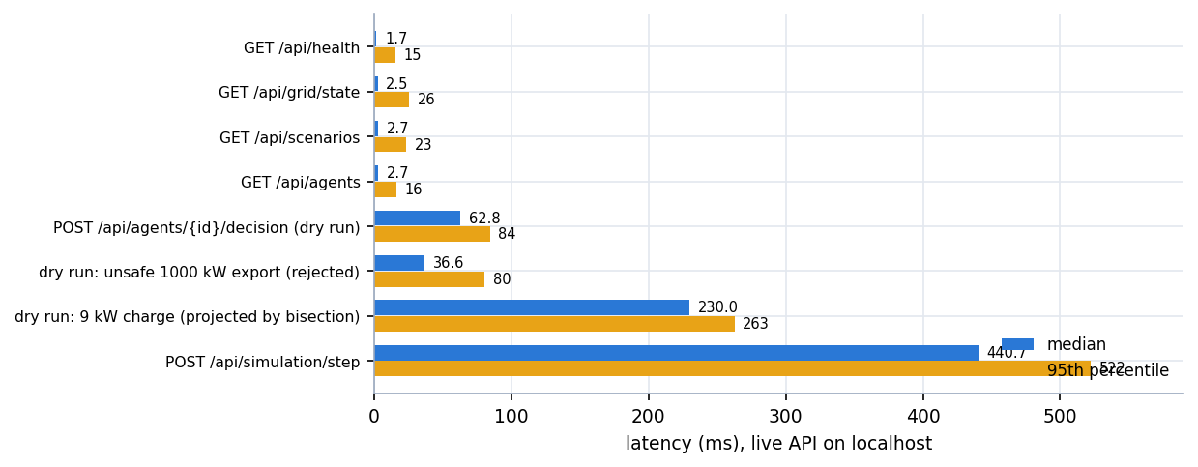
Figure 16: Median and 95th-percentile latency of the live API calls
Read-only calls cost a few milliseconds; the expensive calls run trial power flows. A dry run of the agent's own proposal costs a median of 62.8 ms, a rejected absurd export 36.6 ms (structural checks stop it before any power flow), a projected request 230.0 ms (bisection evaluates many trial power flows) and a full simulation step 440.7 ms.
The batch experiment agrees: the mean step time with the shield is 347.8 ms against 106.2 ms without it (rule baseline 107.9 ms). The shield roughly triples the compute time of a step, the price of validating every action with a real AC power flow; at a 15-minute control interval this is negligible. The decision latency of the mock provider (0.1-0.2 ms) does not represent a real language model, whose latency was not measured.

7.8 User Acceptance Testing
No user acceptance testing was carried out. No operator, instructor or outside user used the system, so statements about usability or trust are not supported by data; only the developers' browser walk-through (Section 7.4) exists. A proper test would give power-systems students or network operators a task script (start a scenario, find the first intervention, explain it, validate a custom action), a comprehension check on the explanation view, a trust and workload questionnaire, and a comparison of the dashboard with and without the explanation lane.

7.9 Testing Limitations
• Two grid tests fail and one API test hangs (Section 7.2); the suite is therefore not green.
• The scenario tests assert the central safety property on the same simulated model that the shield uses to judge actions, so they show consistency of the shield with its model, not agreement with a real network.
• Agent tests use the deterministic mock provider; the real-model provider is exercised only through its output validation and its unconfigured path, because no API key was configured.
• Performance figures come from one desktop machine with other work running, and latency numbers shift between runs.
• There is no load test with concurrent users, no long-duration soak test and no test of the three-dimensional landing page beyond the browser walk-through.
• No user study was conducted.

CHAPTER 8: RESULTS AND OUTPUT SCREENS
This chapter shows the console with real data (Section 8.1), reports the experiment that compares three control strategies on seven scenarios (8.2 to 8.7) and interprets it, including where the shield does not help (8.8 to 8.11). Every number was produced by running this repository; none is quoted from a paper.

8.1 Application Output Screens
All screens were captured from the running application at 1440 x 900 pixels in the dark theme and show one run: scenario unsafe_ai_action, agent brain Mock LLM, seed 42, instant playback, 12 of 12 steps. The scenario injects absurd and malformed proposals so that the shield has something to do.
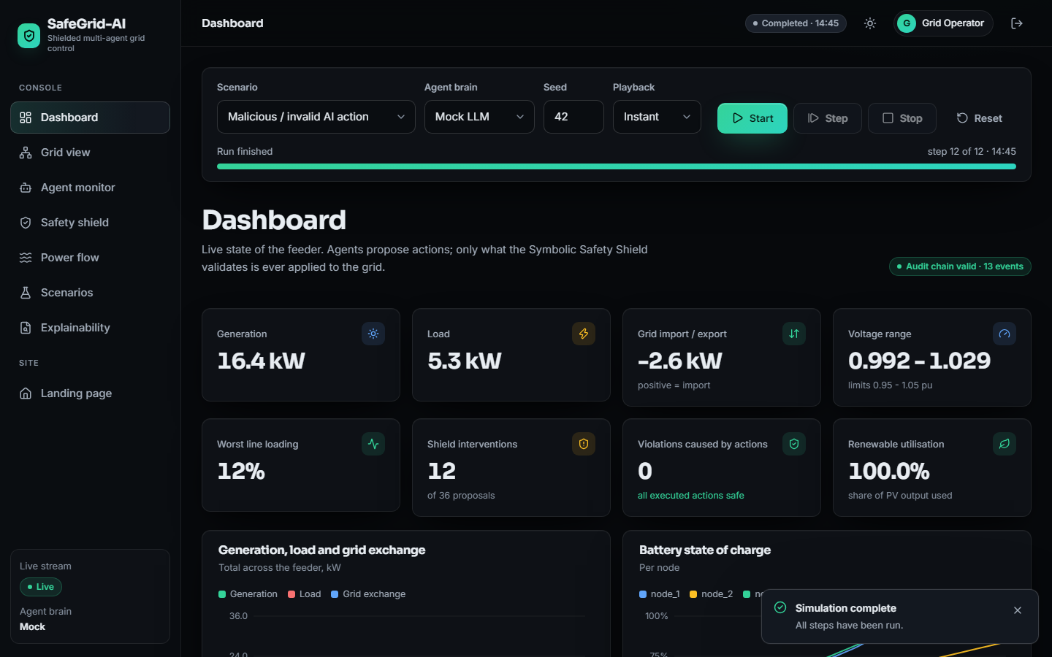
Figure 17: Dashboard after a completed run of the unsafe-action scenario
The status reads Completed 14:45 (step 12 of 12) and a badge reports Audit chain valid, 13 events. At the last step the tiles show generation 16.4 kW, load 5.3 kW, grid exchange -2.6 kW (a net export), voltage range 0.992 to 1.029 pu, worst line loading 12 %, 12 shield interventions out of 36 proposals, 0 violations caused by actions and renewable utilisation 100 %.
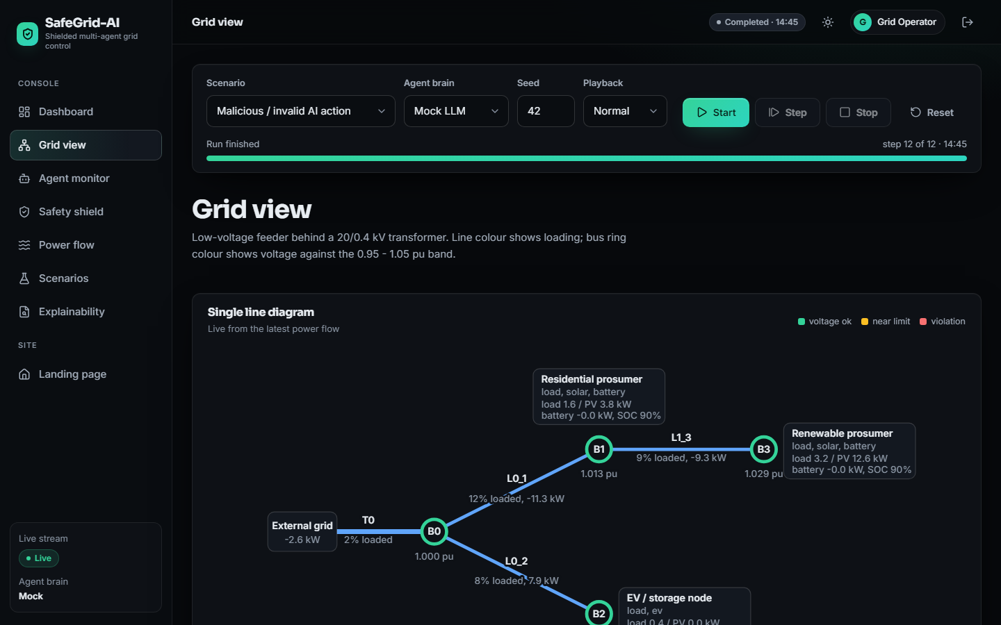
Figure 18: Grid view: single-line diagram of the feeder
The diagram is drawn from the live power-flow result: the external grid exports 2.6 kW, transformer T0 is 2 % loaded, buses B0, B1 and B3 are at 1.000, 1.013 and 1.029 pu, and lines L0_1, L1_3 and L0_2 are at 12 %, 9 % and 8 % loading. Rings and lines turn amber near a limit and red in violation; here all are green.
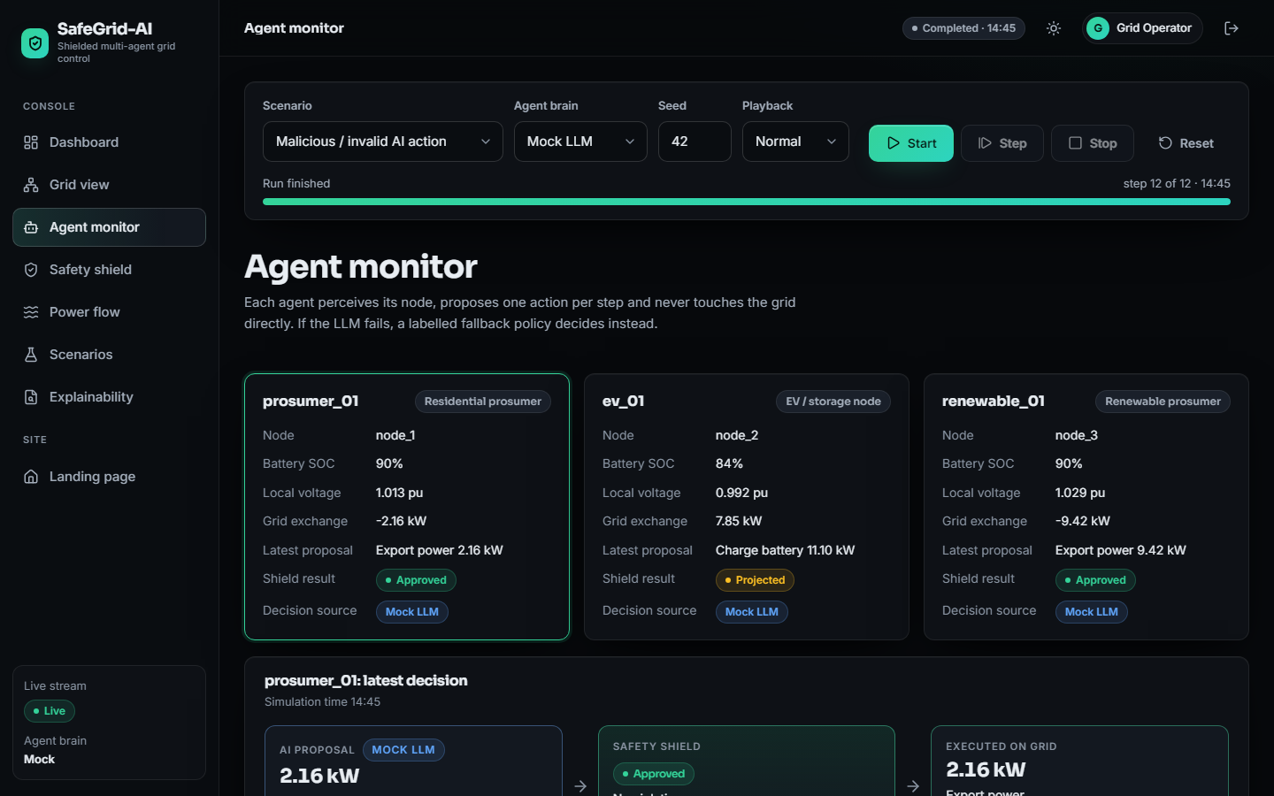
Figure 19: Agent monitor: the three agents and the latest decision
Each card reports node, state of charge, local voltage, exchange, latest proposal, shield result and decision source. prosumer_01 proposed to export 2.16 kW and renewable_01 9.42 kW, both approved; ev_01 (84 %, 0.992 pu) asked to charge at 11.10 kW and the shield marked it Projected, scaled down before execution. All three decisions came from the Mock LLM source.
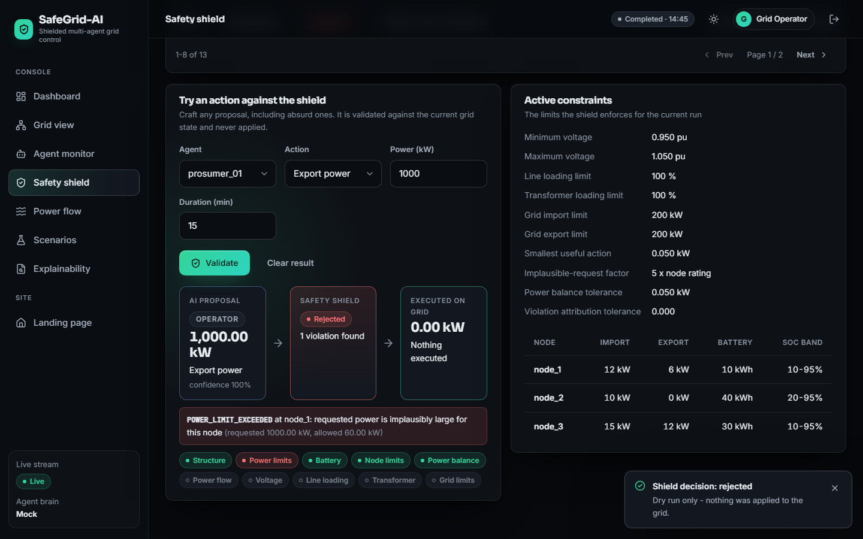
Figure 20: Safety shield: dry run of a 1,000 kW export, and the active constraints
The left panel validates any crafted action against the current grid without applying it. prosumer_01 is asked to export power 1,000 kW for 15 minutes and the shield answers Rejected: POWER_LIMIT_EXCEEDED at node_1: requested power is implausibly large for this node (requested 1000.00 kW, allowed 60.00 kW), with 0.00 kW executed. The check chips show that the power-flow-based checks were not evaluated because rejection happened earlier. The right panel lists the enforced limits: 0.950 to 1.050 pu, 100 % line and transformer loading, 200 kW grid import and export, a 0.050 kW smallest useful action and per-node import, export and state-of-charge limits.
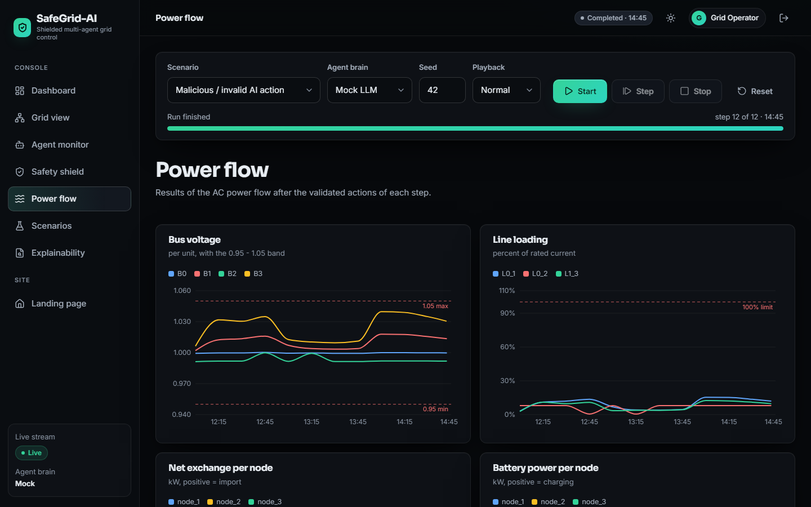
Figure 21: Power flow: bus voltages and line loadings over the run
The screen plots the AC power-flow results of the twelve steps (12:15 to 14:45): bus voltages stay between about 0.99 and 1.04 pu, inside the dashed 0.95 and 1.05 limits, and all line loadings stay below about 15 % against the 100 % limit. Six more charts follow below the capture.
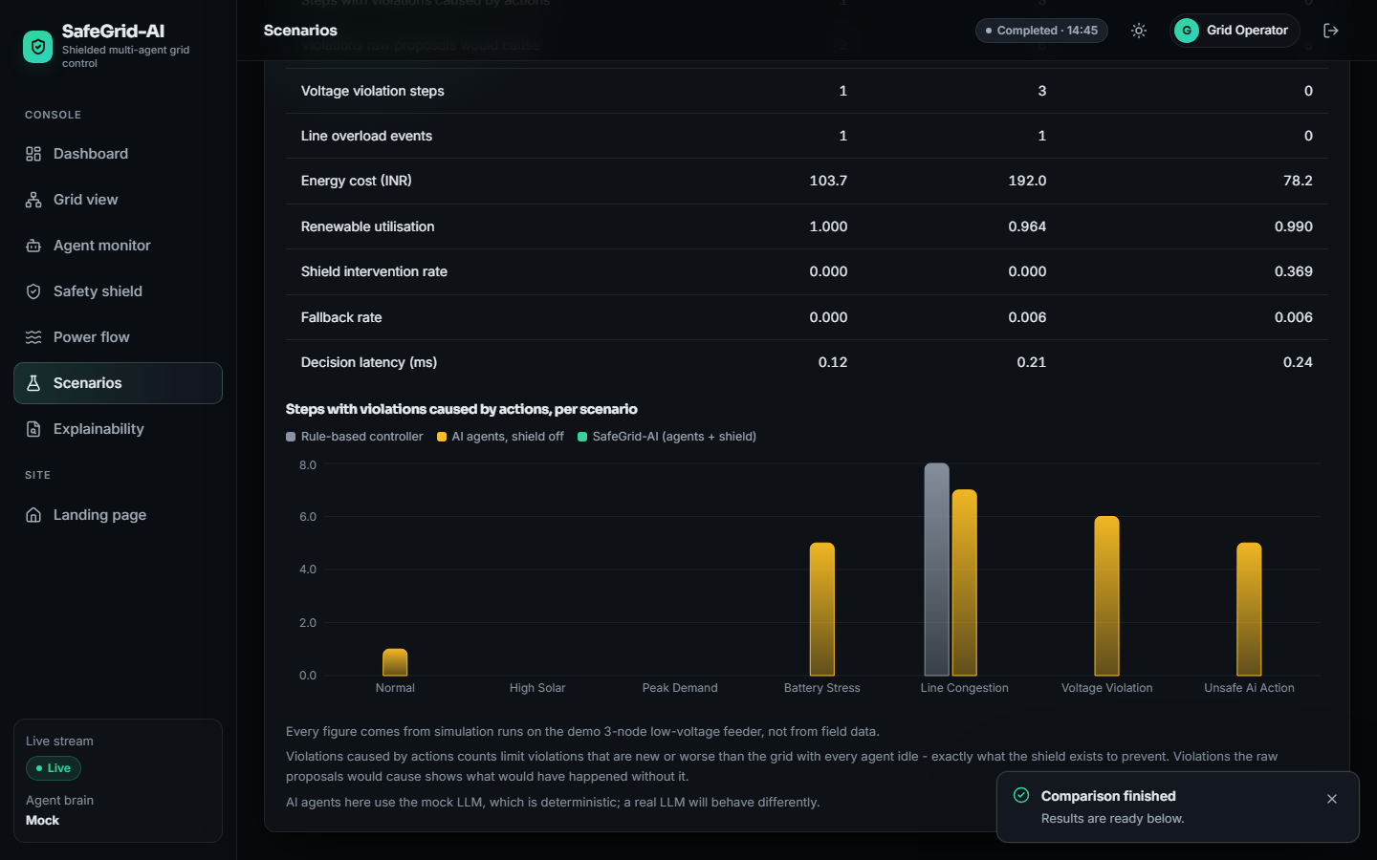
Figure 22: Scenarios: result of the strategy comparison
This capture shows a short comparison with the screen's default settings (one seed, eight steps per run), so its numbers differ from the three-seed, 24-step experiment below. For the rule baseline, the agents without the shield and SafeGrid-AI it reports voltage violation steps 1, 3 and 0, line overload events 1, 1 and 0, and energy cost 103.7, 192.0 and 78.2 INR; SafeGrid-AI's shield intervention rate is 0.369. The chart shows no violations caused by actions for SafeGrid-AI.
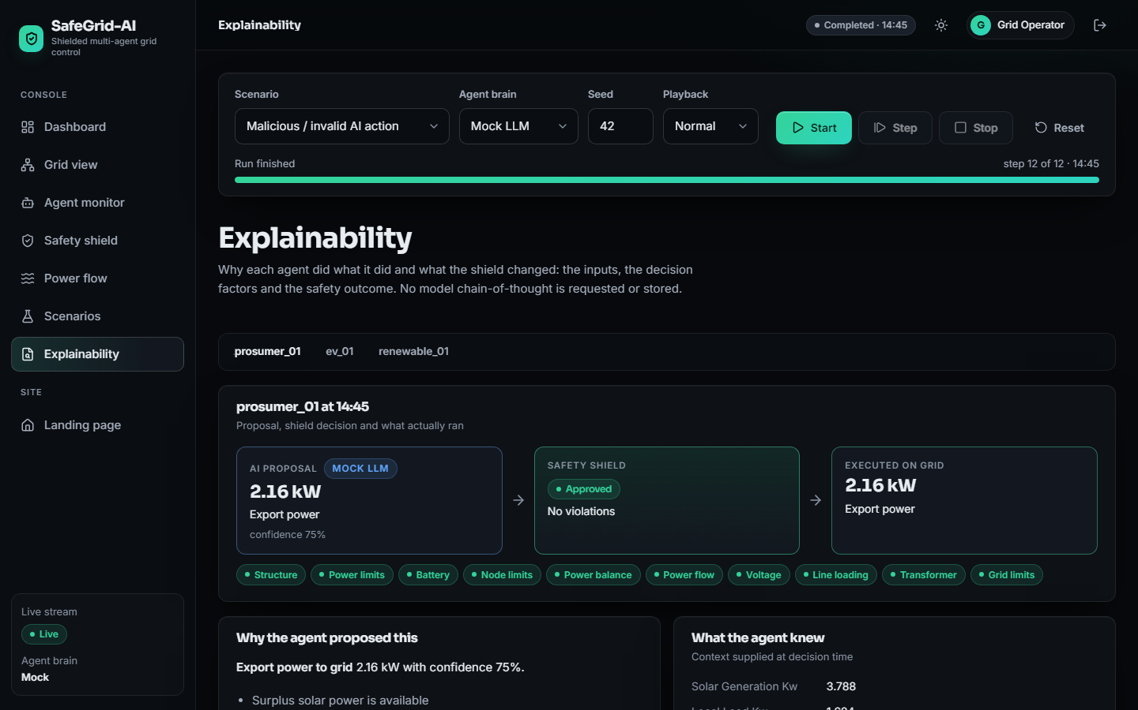
Figure 23: Explainability: proposal, shield decision and executed action for one agent
For prosumer_01 at 14:45 the screen shows the AI proposal (export power 2.16 kW, source Mock LLM, confidence 75 %), the shield decision (Approved, No violations) and the executed action (2.16 kW), ten green check chips, the factor Surplus solar power is available and the context the agent knew (for example solar 3.788 kW). No model chain-of-thought is requested or stored.

8.2 Experimental Setup
Three control strategies (arms) are compared on the three-node feeder of Chapter 5; all arms see identical inputs for a given scenario and seed.
Table 25: Experimental setup
Item | Value
Scenarios | 7: normal, high solar, peak demand, battery stress, line congestion, voltage violation, unsafe AI action
Seeds | 0, 1, 2 (three seeds per scenario and arm)
Steps per run | 24 steps of 15 minutes (6 simulated hours) in every run
Runs | 63 = 7 scenarios x 3 arms x 3 seeds; 21 runs per arm; 504 steps per arm
Arm 1: rule baseline | Non-LLM time-of-use rules, no shield, no fault injection
Arm 2: agents, no shield | Agents with the mock provider and the scenario's injected faults; proposals applied exactly as requested
Arm 3: SafeGrid-AI | Same agents and faults, every proposal validated by the Symbolic Safety Shield
Language model | Deterministic seeded mock provider in every agent run; the real-model provider was not exercised
Machine | Intel Core i5-12500 (6 cores, 12 threads), 15.7 GB RAM, Windows 11 Pro, no GPU used; the 63 runs took about ten minutes
Tariff | Illustrative time-of-use tariff of 3.8 to 9.0 INR per kWh; export credited at 60 % of the import price

Two definitions matter. A violation is caused by an action when it is new, or worse than in the same step with every agent idle; this is what the shield is designed to prevent. A step has pre-existing stress when a limit is violated even with every agent idle; the shield is not designed to remove that. Results are means over seeds. Every run uses 24 steps, longer than the native length of the shorter scenarios (12 to 16 steps), whose injected faults occur early.

8.3 Violations Caused by Executed Actions
Over 21 runs of 24 steps, SafeGrid-AI caused no violation: 0 of 504 shielded steps. The same agents without the shield caused 144 violations in 99 steps; the rule baseline, which has no safety layer either, caused 46 violations in 46 steps, all in line_congestion and peak_demand.
Table 26: Overall comparison of the three strategies (mean per run of 24 steps; 21 runs per strategy)
Metric | Rule baseline | Agents, no shield | SafeGrid-AI
Steps with violations caused by actions (of 24) | 2.19 | 4.71 | 0.00
Violations caused by actions | 2.19 | 6.86 | 0.00
Violations the raw proposals would cause | 6.05 | 8.52 | 9.14
Steps with pre-existing stress (every agent idle) | 6.33 | 6.33 | 6.33
Steps with any violation after execution | 6.05 | 6.38 | 2.48
Voltage violation steps (strict counter) | 4.33 | 4.43 | 3.14
Line overload events (strict counter) | 1.71 | 1.86 | 0.71
Transformer overload events | 0.00 | 0.14 | 0.00
Energy cost per run, INR (illustrative tariff) | 216.4 | 380.8 | 225.0
Renewable utilisation | 1.000 | 0.884 | 0.860
Battery utilisation (throughput / capacity) | 0.520 | 3.392 | 0.508
Shield intervention rate | 0.000 | 0.000 | 0.232
Fallback rate | 0.0000 | 0.0020 | 0.0020
Mean decision latency, ms (mock provider) | 0.103 | 0.160 | 0.168
Mean step time, ms | 107.9 | 106.2 | 347.8

Table 27: Steps with violations caused by actions, per scenario (mean of three seeds, of 24 steps)
Scenario | Rule baseline | Agents, no shield | SafeGrid-AI
normal | 0.00 | 1.67 | 0.00
high solar | 0.00 | 0.67 | 0.00
peak demand | 3.33 | 4.00 | 0.00
battery stress | 0.00 | 4.67 | 0.00
line congestion | 12.00 | 11.33 | 0.00
voltage violation | 0.00 | 6.33 | 0.00
unsafe ai action | 0.00 | 4.33 | 0.00
all scenarios (mean) | 2.19 | 4.71 | 0.00

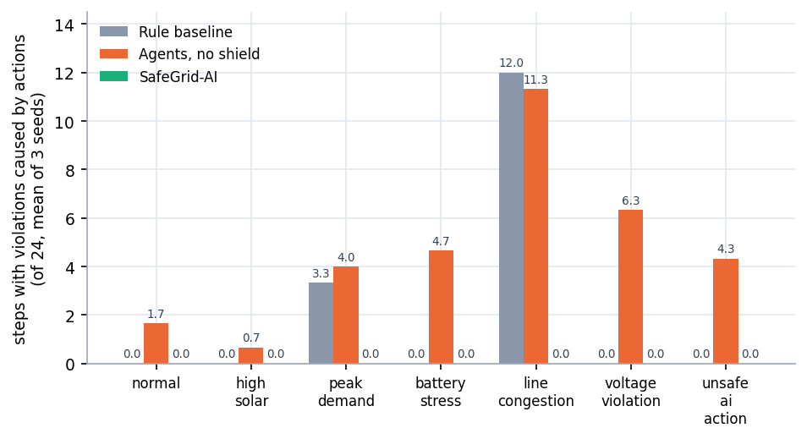
Figure 24: Steps with violations caused by actions, per scenario and strategy (mean of three seeds)
Without the shield the agents cause violations in every scenario, from 0.67 steps in high_solar to 11.33 in line_congestion; the injected faults of unsafe_ai_action give 4.33. The rule baseline is safe in five scenarios but fails in line_congestion (12.00 steps) and peak_demand (3.33): its rules charge the vehicle at the full available rate (BASELINE_UNCONTROLLED_EV_CHARGING) on a feeder with reduced ampacity. The shield brings the count to zero everywhere because it checks the consequences of an action, not its intention.
The strict counters in the overall table (voltage violation steps 3.14, line overload events 0.71) are not zero for SafeGrid-AI. They use a tighter tolerance than the shield (1e-9 pu against 1e-6 pu; 1e-6 % against 1e-4 %), and projection places a quantity exactly on its limit, so a step can be counted although the shield accepts it. The size of those excesses was not measured; the attribution counters are the primary evidence.

8.4 What the Shield Decided
Across 21 shielded runs (1,512 agent proposals) the shield approved 1,162 (76.9 %), projected 237 (15.7 %) and rejected 113 (7.5 %), and no executed action created or worsened a limit violation (0 of 504 steps), whereas the same agents without the shield did so in 99 steps (144 violations). Across the 21 runs the shield also wrote 354 safety-log events, the coordinator reported 241 conflicts, and the hash chain verified in 21 of 21 runs.
Table 28: Shield decisions per scenario, SafeGrid-AI arm (mean per run of three seeds)
Scenario | Proposals | Approved | Projected | Rejected | Raw-proposal violations | Pre-existing stress steps | Cost (INR)
normal | 72 | 59.7 | 8.7 | 3.7 | 1.7 | 0.3 | -16.7
high solar | 72 | 55.7 | 12.0 | 4.3 | 2.3 | 20.0 | -97.6
peak demand | 72 | 61.0 | 9.0 | 2.0 | 14.0 | 12.0 | 1126.4
battery stress | 72 | 52.0 | 12.0 | 8.0 | 5.3 | 3.0 | -57.0
line congestion | 72 | 45.7 | 23.0 | 3.3 | 16.0 | 0.0 | 580.8
voltage violation | 72 | 57.3 | 6.3 | 8.3 | 12.7 | 6.7 | 61.5
unsafe ai action | 72 | 56.0 | 8.0 | 8.0 | 12.0 | 2.3 | -22.7

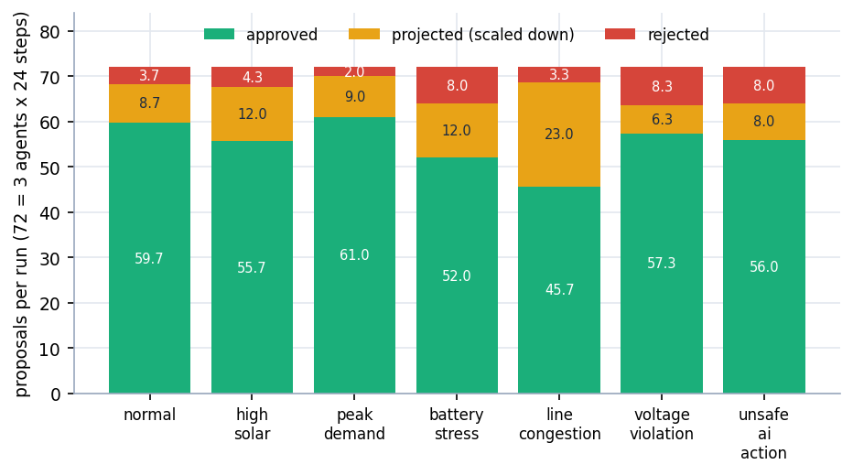
Figure 25: Approved, projected and rejected proposals per run and scenario (SafeGrid-AI arm)
The shield approved 76.9% of proposals, projected 15.7% and rejected 7.5%; the intervention rate rises from 15.3 % in peak_demand to 36.6 % in line_congestion, where almost every EV charging request has to be scaled down. The same proposals would have caused 16.0 violations per run in line_congestion and 14.0 in peak_demand without the shield. Projection is more common than rejection (237 against 113), so the shield usually keeps the agent's intent and reduces its size.

8.5 Pre-existing Grid Stress
Some violations exist even when no agent acts. The shield does not repair them by design, but relief-first ordering and projection can reduce them; the table shows the steps that still carried any violation after execution.
Table 29: Steps with any violation after execution, per scenario (mean of three seeds, of 24 steps)
Scenario | Stress with every agent idle | Rule baseline | Agents, no shield | SafeGrid-AI
normal | 0.3 | 0.3 | 1.7 | 0.0
high solar | 20.0 | 16.7 | 2.7 | 1.7
peak demand | 12.0 | 7.3 | 13.7 | 8.7
battery stress | 3.0 | 0.0 | 4.7 | 1.7
line congestion | 0.0 | 12.0 | 11.3 | 0.0
voltage violation | 6.7 | 6.0 | 6.3 | 4.3
unsafe ai action | 2.3 | 0.0 | 4.3 | 1.0
all scenarios (mean) | 6.33 | 6.05 | 6.38 | 2.48

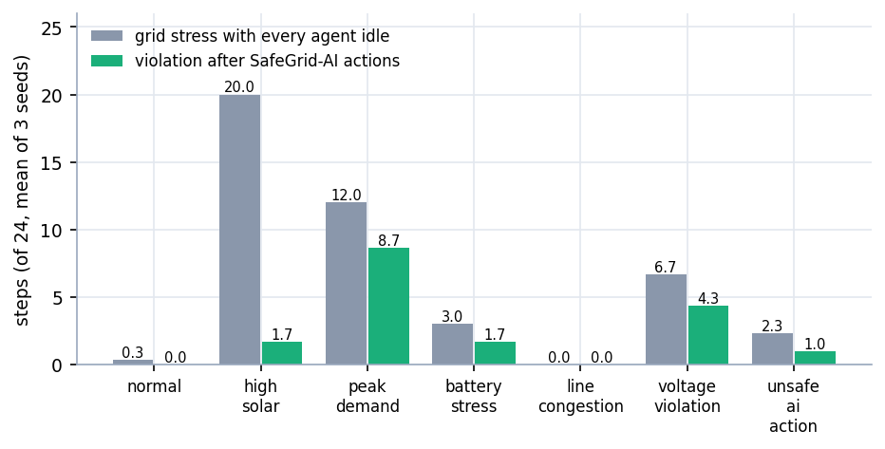
Figure 26: Grid stress with every agent idle compared with violations after SafeGrid-AI actions
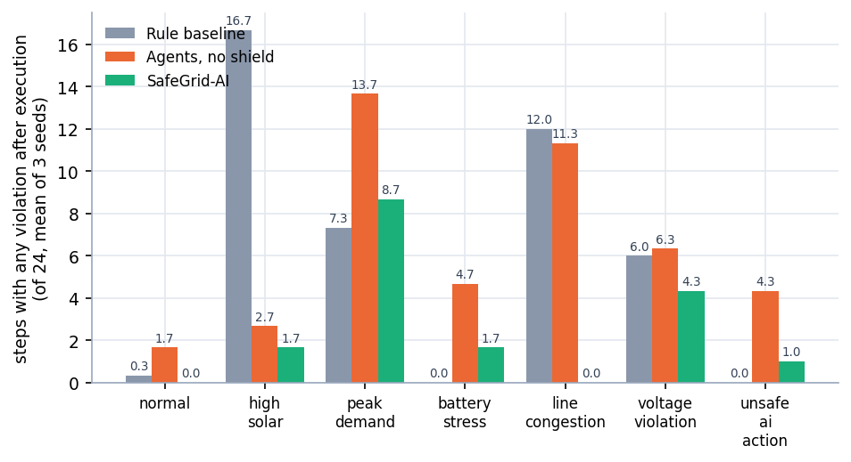
Figure 27: Steps with any violation after execution, per scenario and strategy
Averaged over scenarios, 6.05 steps per run carry a violation under the rule baseline, 6.38 without the shield and 2.48 with SafeGrid-AI, against 6.33 steps of stress with every agent idle. The reduction comes mostly from high_solar (20.0 stress steps with everyone idle, 1.7 after SafeGrid-AI), where the agents absorb surplus solar in their batteries; removing violations was not the shield's guarantee, and Section 8.8 shows where the gain does not appear.

8.6 Cost of Safety
A safety layer is not free; the table and figures show the trade-offs.
Table 30: Energy cost per run (INR, illustrative tariff) and renewable utilisation, per scenario
Scenario | Cost: rule | Cost: no shield | Cost: SafeGrid | RU: rule | RU: no shield | RU: SafeGrid
normal | -108.7 | -6.7 | -16.7 | 1.000 | 0.794 | 0.765
high solar | -267.6 | -56.6 | -97.6 | 1.000 | 0.554 | 0.607
peak demand | 1285.0 | 1197.5 | 1126.4 | 1.000 | 1.000 | 1.000
battery stress | -53.1 | -35.1 | -57.0 | 1.000 | 1.000 | 1.000
line congestion | 664.9 | 633.3 | 580.8 | n/a | n/a | n/a
voltage violation | 29.6 | 47.4 | 61.5 | 1.000 | 0.959 | 0.787
unsafe ai action | -35.4 | 885.8 | -22.7 | 1.000 | 1.000 | 1.000

RU is renewable utilisation (the share of available solar output that was used); it is not defined in line_congestion, which has no available solar generation, and is printed as n/a.
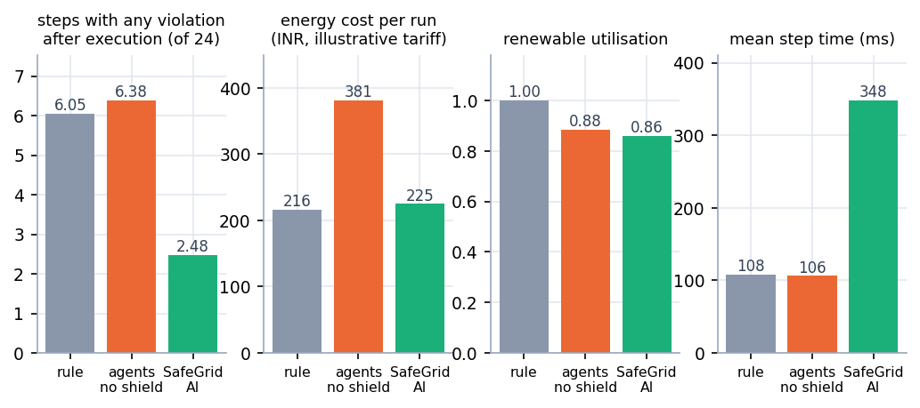
Figure 28: Overall comparison: violations after execution, cost, renewable utilisation and step time
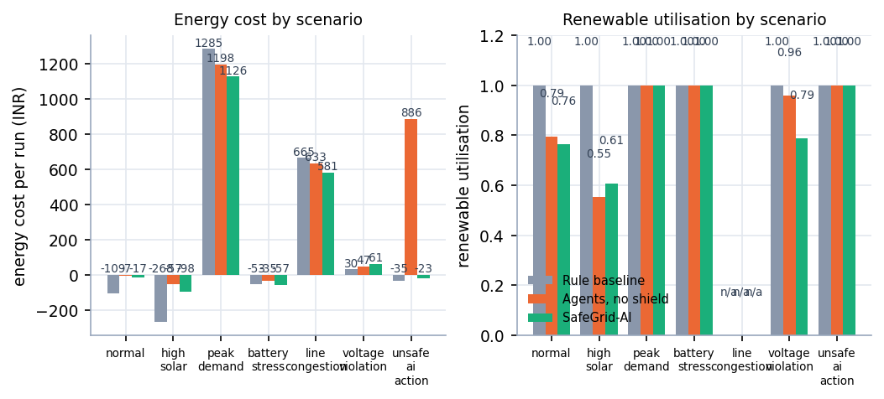
Figure 29: Energy cost and renewable utilisation per scenario
• Cost. Mean cost per run is 225.0 INR with the shield, 380.8 without it and 216.4 for the rule baseline. The unshielded agents are dear mainly because of unsafe_ai_action, where an injected 900 kW import raises the cost to about 886 INR per run against -22.7 with the shield. SafeGrid-AI is slightly dearer than the rule baseline overall but cheaper in peak_demand and line_congestion.
• Renewable utilisation. The rule baseline uses all available solar; the shielded arm uses 0.860. The cost shows in high_solar (0.607) and voltage_violation (0.787), where the shield limits export to protect voltage; unshielded agents do worse in high_solar (0.554).
• Battery use. Throughput divided by capacity is 0.508 with the shield, 0.520 for the rule baseline and 3.392 for the unshielded agents, dominated by unsafe_ai_action (18.8 times capacity per run).
• Compute. Mean step time rises from about 106 ms to 348 ms, with 834 ms in line_congestion, where nearly every proposal needs bisection. The mock provider's 0.17 ms decision latency is meaningless for a real model.

8.7 Single-Run Traces
Three single runs (seed 42, native length, shield on and off) show what the averages hide.
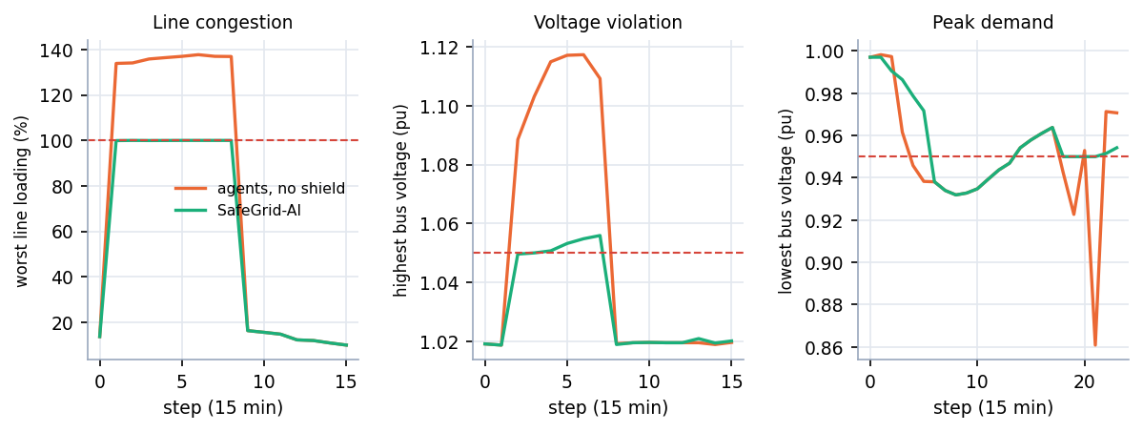
Figure 30: Single-run traces with and without the shield: line loading, highest bus voltage and lowest bus voltage
Table 31: Worst values in the three traced runs
Scenario | Quantity | Agents, no shield | SafeGrid-AI | Limit
line congestion | worst line loading | 137.7 % | 100.0 % | 100 %
voltage violation | highest bus voltage | 1.117 pu | 1.056 pu | 1.05 pu
peak demand | lowest bus voltage | 0.861 pu | 0.932 pu | 0.95 pu

In line_congestion the unshielded agents drive the feeder to 137.7 % of its rating for eight steps; with the shield the loading is projected exactly onto the 100 % limit and never above it. In voltage_violation the voltage climbs to 1.117 pu without the shield and peaks at 1.056 pu with it, still above 1.05 pu because the scenario's weak feeder is already out of band when the agents are idle. In peak_demand the lowest voltage is 0.861 pu without the shield and 0.932 pu with it, still below 0.95 pu because the evening peak itself is the stressor. The shield removes the excess that actions add and leaves the stress that the scenario creates.

8.8 Analysis of Successful and Failure Cases

Where the shield works
• Agent faults. In unsafe_ai_action the unshielded agents cause violations in 4.33 steps per run and the shielded agents in none. The 1,000 kW export and the 900 kW import are rejected; a malformed output becomes a labelled fallback decision that is shielded like any other.
• Congestion by a non-AI controller. The rule baseline causes violations in 12.00 of 24 steps in line_congestion. The shielded agents face the same congested feeder and cause none. No arm combines the rule controller with the shield, so that pairing is not claimed.
• Plausible-but-oversized requests. About one proposal in six is projected, not rejected: the agent wanted the right thing at the wrong size, and the shield returns the largest safe part of it.

Where it does not help, or helps less
• Pre-existing stress remains. high_solar has 20.0 stress steps out of 24 with every agent idle, and peak_demand has 12.0; after SafeGrid-AI actions peak_demand still shows 8.67 steps with a violation.
• A rule controller can leave fewer violations in peak demand. Steps with any violation after execution in peak_demand are 7.33 for the rule baseline, 8.67 for SafeGrid-AI and 13.67 without the shield. The shield prevents harm but does not search for relief; this is a real limitation of a veto-style layer and the reason future work proposes a planner rewarded for resolving violations.
• Renewable energy is sometimes given up. Utilisation falls to 0.607 in high_solar and 0.787 in voltage_violation.
• Strict counters are not zero (3.14 and 0.71), for the tolerance reason in Section 8.3, and everything depends on the model: the shield is only as good as the simulated grid it asks.

8.9 Discussion of Limitations
The results support one limited claim: in this simulator, under these scenarios, with a deterministic stand-in for a language model, validating every action with an AC power flow prevents all new or worsened limit violations, at the cost of some renewable energy and about three times the compute per step. The limits of the evidence are:
• Every agent result comes from the deterministic mock provider; no live language model was evaluated, so language-model reasoning quality and real inference latency are unmeasured.
• The batch objective 'violation resolution rate' was not measured; the project measures violations prevented (caused by actions = 0) and steps with any violation, not repair of a grid that is already outside its limits.
• Mean decision latency is 0.1-0.2 ms for the mock provider and says nothing about a real model.
• Three seeds, a three-node synthetic feeder, an illustrative tariff, no protection, no dynamics and no three-phase unbalance.
• The guarantee is model-relative (no new or worse violations in the simulated model), not a formal proof; the abstract's 'mathematically guaranteeing zero physical constraint violations' is stronger than what was built and tested.
• The comparison with the base paper is qualitative: different system, no shared benchmark, no like-for-like numbers.
• Two unit tests fail on numeric tolerances with pandapower 3.5.6 and one WebSocket test hangs under the installed Starlette test client.
• No user study was carried out, so usability and operator trust are not measured.
Three seeds do not support confidence intervals, and means over scenarios mix very different situations, so the per-scenario tables are more informative than the overall one.

8.10 Objectives versus Outcomes
Table 32: Objectives of the project and what was delivered
Objective | Status | Evidence
1. Multi-agent grid model | Achieved | Three agents (prosumer, EV storage, renewable prosumer) on a 3-node pandapower feeder; a coordinator detects peer mismatch, target contention and shared-feeder conflicts.
2. LLM planning agent | Achieved with a mock model | Agents build a structured context and obtain a schema-validated EnergyAction from a provider. A real-LLM provider (Anthropic / OpenAI wire format) is implemented but was not run against a live model; all measured results use the deterministic mock provider.
3. Safety shielding | Achieved | Symbolic Safety Shield with ten ordered checks and bisection projection: 0 violations caused by executed actions in all 504 shielded steps (1,512 proposals).
4. Explanations | Achieved | Every decision carries inputs, decision factors, the action, the safety result and a reason code list; no chain-of-thought is requested or stored (tested).
5. Fault and overload scenarios | Achieved | Seven seeded scenarios, including injected unsafe and malformed proposals; the shield rejected or scaled down 350 of 1,512 proposals.
6. Evaluation metrics | Partly achieved | Unsafe actions blocked (113 rejected, 237 projected) and decision latency were measured. A violation-resolution rate for pre-existing violations was not measured: the project measures violations prevented, not violations repaired.

8.11 Comparison with the Base Paper
The base paper [1] designs a rule-based multi-agent energy management system for a DC microgrid and validates it in MATLAB/Simulink in eight scenarios. SafeGrid-AI differs in the system modelled, in how decisions are made and in what is measured, so no numeric comparison is possible or attempted. Grid-Agent [2] is closer in spirit, but its safety rests on sandboxed execution with rollback and its results are success rates on IEEE and CIGRE networks, on which this project did not run. The table compares design and evidence qualitatively.
Table 33: SafeGrid-AI compared with the base paper (qualitative)
Aspect | Base paper [1] | SafeGrid-AI
System modelled | DC microgrid, 800 V bus, MATLAB/Simulink | Three-node AC low-voltage feeder, pandapower AC power flow
Decision makers | Four rule-based agents | Three agents driven by a pluggable LLM provider (mock in all measurements), with a deterministic fallback
Safety mechanism | Control logic keeps the bus voltage regulated; no separate validation layer | Independent Symbolic Safety Shield: approve, project or reject every action before it is executed
Explanation | None reported | Structured explanation per decision, hash-chained audit log, dashboard views
Evidence | Eight Simulink scenarios, bus voltage regulated at 800 V | Seven scenarios x 3 strategies x 3 seeds (63 runs): 0 violations caused by executed actions in 504 shielded steps
Validation reached | Simulation only; authors note the lack of experimental validation | Simulation only; synthetic profiles; mock LLM; no field data

It supports the gap stated in the batch survey: an independent, deterministic safety layer with explanations and an audit trail is what this project adds and measures, within the limits above.

CHAPTER 9: CONCLUSION

9.1 Summary of the Work
SafeGrid-AI is a simulation-based system in which three agents (a residential prosumer, an electric-vehicle storage node and a renewable prosumer) propose one EnergyAction per 15-minute step for a small low-voltage feeder, and a deterministic Symbolic Safety Shield decides what reaches the grid. A coordinator orders the proposals, relief actions first, and the shield validates each one against the cumulative grid state with a real AC power flow (pandapower [11]): approved, projected (scaled to the largest safe size by bisection) or rejected, with every non-approved decision entered in a SHA-256 hash-chained log. A FastAPI service and a React console expose run controls, a live single-line diagram, an agent monitor, a shield view with a dry-run tool, power-flow charts, a scenario runner and an explainability view.
The evaluation used seven scenarios, three seeds and three strategies, 63 runs of 24 steps. The language model in every run was a deterministic mock provider, which limits what the results can say.

9.2 Objectives Achieved and Main Contributions
Of the six objectives, four were achieved in full (multi-agent model, safety shield, explanations, scenarios), one with a mock model in place of a real one (the language-model planner) and one in part (evaluation: unsafe actions blocked and decision latency were measured, a violation-resolution rate was not). Section 8.10 gives the evidence.
The contributions beyond assembling known parts are modest and specific: a verdict that can reduce an action instead of only vetoing it; an attribution rule that separates violations caused by an action from pre-existing stress; a shield whose independence from the language-model code is enforced by a test; explanations built from structured data; a tamper-evident audit trail; and an evaluation that includes the counterfactual of what the raw proposals would have done.

9.3 Key Findings
1. Across 21 shielded runs (1,512 agent proposals) the shield approved 1,162 (76.9 %), projected 237 (15.7 %) and rejected 113 (7.5 %), and no executed action created or worsened a limit violation (0 of 504 steps), whereas the same agents without the shield did so in 99 steps (144 violations).
2. The rule-based baseline, which has no safety layer, also caused violations (46 in 46 steps), all in the congestion and peak-demand scenarios, so the failure is not specific to language-model agents.
3. The shield intervened on 350 of 1,512 proposals (23.1%): 237 projected and 113 rejected, so the agent's intent is usually kept at a smaller size.
4. Steps with any violation after execution average 6.05 for the rule baseline, 6.38 without the shield and 2.48 with it, against 6.33 steps of stress when every agent is idle. Not all stress is removed, and in peak_demand the rule baseline leaves fewer violations than the shielded agents.
5. Safety has a price: mean step time is 347.8 ms with the shield against about 106 ms without it, and renewable utilisation is 0.860 against 1.000 for the rule baseline; mean energy cost is 225.0 INR against 380.8 without the shield.
6. The audit chain verified in all 21 shielded runs, and a forged event is detected by the tests.

9.4 Practical Applications
The system is a research and teaching prototype, not a controller for a real network. Within that limit it serves four purposes.
• Teaching and demonstration. Students can watch an agent propose an unsafe action, see which check stopped it and read why, with every number reproducible from a seed.
• A test bench for agent controllers. Any controller that can emit an EnergyAction can be dropped in behind the provider interface and compared on the same scenarios, with and without the shield.
• A pattern for supervising AI agents on physical systems. An independent, deterministic validator and a record of every decision apply to other domains with hard limits.
• A starting point for operator-facing tools. The dry-run view, decision lane and audit chain are the beginnings of a review interface.

9.5 Known Limitations
The conclusions hold only for the simulated three-node feeder, three seeds and the mock provider: no real language model was evaluated (reasoning quality and real latency are unknown); violation resolution was not measured; the guarantee is relative to the simulator and is not a formal proof; the comparison with the base paper is qualitative; two grid tests fail and one WebSocket test hangs; and no user study was done.

CHAPTER 10: FUTURE SCOPE

10.1 Possible Improvements
• Run a real language model. Configure the existing API provider with a hosted model, repeat the 63-run experiment, and report decision latency, token cost, fallback rate and schema-invalid outputs. This is the most valuable next step, because every agent result here comes from a mock.
• Repair the test suite. Compute the expected values in the two grid tests instead of fixing them, and use an asynchronous client for the WebSocket test.
• Measure resolution. Add a metric for the share of pre-existing violation steps that are cleared, and a planner objective that rewards clearing them; peak_demand shows a veto-only layer can be out-performed by a controller that acts helpfully.
• Reduce the cost of safety. Use cached factorisations or sensitivity screening to avoid a full trial power flow for clearly safe proposals; the shield roughly triples the step time.
Two smaller improvements follow from the experiment. A randomised scenario library, with faults, weather, loads and starting states drawn from distributions, would test the safety claim on hundreds of situations and support confidence intervals instead of means over three seeds. The strict counters for voltage and line loading (Section 8.3) should use the shield's own tolerance, so that a quantity placed exactly on its limit by projection is not counted by one counter and accepted by another.

10.2 Additional Features
• Human-in-the-loop approval. Hold projected or rejected actions for an operator to accept, edit or override, recorded in the same hash chain, in line with the human-oversight requirements discussed for grid studies [3].
• Tool interface. Expose the simulator and the shield through the Model Context Protocol [3] so that external agents can call them as standard tools.
• Forecast-aware agents. Give the agents solar and load forecasts so that they can plan over several steps, with the shield still validating each step.
• Authentication and roles. Replace the browser-side demo gate with real accounts and keep the model API key on the server.
A fifth feature is a replay mode: because every run has a seed, a configuration and a hash-chained log, a past run can be replayed in the dashboard and a changed constraint (for example a 0.97 pu lower voltage limit) applied to the same proposals to see which decisions would change, which turns the audit trail into a tool for tuning limits and post-incident review.

10.3 Scalability and Deployment
• Larger networks. Repeat the study on benchmark feeders of the kind used in related work [2]; trial power flows per step grow with the number of agents and the bisection depth, so scaling must be measured, not assumed.
• Three-phase operation. Move from the single-phase equivalent to a three-phase model, because low-voltage feeders are often unbalanced and voltage limits are phase-wise.
• Operational packaging. Containerise the services, move the store to a server database, add structured logging and run the experiment runner as a scheduled job.
• Hardware in the loop. Connect the shield to a real-time simulator before any field device, since the quasi-static 15-minute model hides fast dynamics and protection.
The shield is the part that must be most reliable, so it should be versioned separately from the agents, deployed with its constraint file under change control and tested against a fixed library of proposals on every release. At hundreds of agents the cost of trial power flows would need sensitivity screening or a distributed validator.

10.4 Further Research Directions
• Formal verification of the shield. State the guarantee as a theorem about a stated model (monotone projection, the attribution rule, the tolerance) and check it with a verifier, in the spirit of shielding for safe learning [12].
• Learning with a shield in the loop. Train a policy by reinforcement learning or fine-tuning with the shield's corrections as part of the signal, so that agents propose actions that need less projection [13], [14].
• Faithful explanations. Compare structured explanations with model-written rationales for operator comprehension and faithfulness [17].
• User study. Test with students and operators whether the decision lane, dry run and audit view improve understanding, trust and error detection.
• Adversarial evaluation. Attack the provider with prompt injection and measure what reaches the grid; the schema and shield should make the answer 'nothing', but only synthetic faults were tested.
A final direction is the relationship between shield and planner: today the shield is a veto with repair and the planner sees its corrections only in the next context. A bounded propose, validate, revise loop within one step is the closest analogue to the validation agent of Grid-Agent [2] and would allow a like-for-like comparison.

REFERENCES
[1] S. E. Eyimaya and N. Altin, "Design of multi-agent-based energy management system for DC microgrids," IEEE Access, vol. 14, pp. 39120-39133, 2026, doi: 10.1109/ACCESS.2026.3672618.
[2] Y. Zhang, A. M. Saber, A. Youssef, and D. Kundur, "Grid-Agent: An LLM-powered multi-agent system for power grid control," arXiv:2508.05702, Aug. 2025.
[3] J. Picault and C. Goubet, "Orchestrating power grid studies with multi-agent AI and MCP servers," arXiv:2607.14158, Jul. 2026.
[4] "Multi-agent deep reinforcement learning for energy-efficient smart grid management," in Proc. 1st Int. Conf. Intelligent Methods and Advanced Computer Scientific Innovations, 2025. (Authors not recorded in the batch survey.)
[5] "Energy system fault reconstruction control strategy based on multi-agent deep reinforcement learning," in Proc. 6th Int. Conf. Energy, Power and Grid (ICEPG), 2024. (Authors not recorded in the batch survey.)
[6] "Distributed optimal scheduling for electric vehicles considering the multi-agent demands of electric vehicles, charging stations and power grid," in Proc. 3rd Int. Conf. Power, Grid and Energy Storage, 2025. (Authors not recorded in the batch survey.)
[7] "Multi-agent systems in power system: A comprehensive review of energy management in power grid," in Smart Grid Security and Protection, Lecture Notes in Electrical Engineering, 2025. (Authors not recorded in the batch survey.)
[8] S. D. J. McArthur et al., "Multi-agent systems for power engineering applications - Part I: Concepts, approaches, and technical challenges," IEEE Trans. Power Syst., vol. 22, no. 4, pp. 1743-1752, Nov. 2007, doi: 10.1109/TPWRS.2007.908471.
[9] R. H. Lasseter, "MicroGrids," in Proc. IEEE Power Eng. Soc. Winter Meeting, vol. 1, 2002, pp. 305-308, doi: 10.1109/PESW.2002.985003.
[10] H. Farhangi, "The path of the smart grid," IEEE Power Energy Mag., vol. 8, no. 1, pp. 18-28, Jan./Feb. 2010, doi: 10.1109/MPE.2009.934876.
[11] L. Thurner et al., "pandapower - An open-source Python tool for convenient modeling, analysis, and optimization of electric power systems," IEEE Trans. Power Syst., vol. 33, no. 6, pp. 6510-6521, Nov. 2018, doi: 10.1109/TPWRS.2018.2829021.
[12] M. Alshiekh, R. Bloem, R. Ehlers, B. Konighofer, S. Niekum, and U. Topcu, "Safe reinforcement learning via shielding," in Proc. AAAI Conf. Artif. Intell., 2018, pp. 2669-2678.
[13] G. Dalal, K. Dvijotham, M. Vecerik, T. Hester, C. Paduraru, and Y. Tassa, "Safe exploration in continuous action spaces," arXiv:1801.08757, 2018.
[14] J. Garcia and F. Fernandez, "A comprehensive survey on safe reinforcement learning," J. Mach. Learn. Res., vol. 16, pp. 1437-1480, 2015.
[15] D. Amodei, C. Olah, J. Steinhardt, P. Christiano, J. Schulman, and D. Mane, "Concrete problems in AI safety," arXiv:1606.06565, 2016.
[16] S. Yao et al., "ReAct: Synergizing reasoning and acting in language models," in Proc. Int. Conf. Learn. Represent. (ICLR), 2023.
[17] M. Turpin, J. Michael, E. Perez, and S. R. Bowman, "Language models don't always say what they think: Unfaithful explanations in chain-of-thought prompting," in Proc. Adv. Neural Inf. Process. Syst. (NeurIPS), 2023.
[18] M. Wooldridge, An Introduction to MultiAgent Systems, 2nd ed. Chichester, U.K.: Wiley, 2009.
[19] Voltage Characteristics of Electricity Supplied by Public Electricity Networks, European Standard EN 50160:2010, CENELEC, 2010.
[20] Secure Hash Standard (SHS), Federal Information Processing Standards Publication FIPS 180-4, NIST, Aug. 2015.

APPENDIX A: IMPORTANT CODE
The excerpts below are read from the source files of the project when this report is built, so they always match the delivered code; long functions are cut at about 45 lines (marked with ...). Paths are relative to backend/app/. The explanation of each excerpt is in Chapters 5 and 6.

A.1 The action schema (`models/actions.py`)
Everything an agent or a language model may say is one EnergyAction. Unknown fields are forbidden, numbers are bounded and finite, and reason codes have a fixed pattern.
class EnergyAction(BaseModel):
"""A *proposal*. It has no ability to execute anything."""

model_config = ConfigDict(extra="forbid")

agent_id: str = Field(min_length=1, max_length=64)
action_type: ActionType
power_kw: float = Field(ge=0, le=1_000_000, allow_inf_nan=False)
duration_minutes: int = Field(ge=1, le=1440)
target_node: str | None = Field(default=None, max_length=64)
reason_codes: list[str] = Field(default_factory=list, max_length=8)
confidence: float = Field(ge=0.0, le=1.0, allow_inf_nan=False)

@field_validator("reason_codes")
@classmethod
def _reason_codes_are_codes(cls, v):
for code in v:
if not isinstance(code, str) or not _REASON_RE.match(code):
raise ValueError(f"reason code {code!r} must match [A-Z0-9_]{{1,48}}")
return v

A.2 Shield evaluation, steps 1 to 3 (`safety/shield.py`)
Structural checks, the idle shortcut, and the evaluation of the request exactly as proposed. Only violations that are new or worse than the no-action state count.
def evaluate(self, action: EnergyAction, node: NodeView | None, *, trial: TrialFn, current: GridTrial,
dt_minutes: int, known_agents: set[str], known_nodes: set[str]) -> ShieldDecision:
cfg = self.cfg
dt_h = dt_minutes / 60.0
lim = cfg.node_limits.get(node.node_id) if node is not None else None

# 1. structural / sanity checks -> reject
sv = validator.structural_violations(action, node, lim, cfg, known_agents, known_nodes)
if sv:
return self._decision(ShieldStatus.REJECTED, action, None, sv, [], Setpoint(), 0.0, current, current, False)

# 2. idle is always safe (still recorded)
if action.action_type == "idle" or action.power_kw <= validator.EPS:
validated = action.model_copy(update={"duration_minutes": dt_minutes})
corr = self._duration_correction(action, dt_minutes)
return self._decision(ShieldStatus.APPROVED, action, validated, [], corr, Setpoint(), 0.0, current, current, False)

sp_req = validator.resolve_setpoint(action.action_type, action.power_kw, node)
base_local = validator.local_violations(Setpoint(), node, lim, dt_h)
base_grid = validator.check_grid(current, cfg)

def local_new(sp: Setpoint) -> list[Violation]:
return validator.new_violations(validator.local_violations(sp, node, lim, dt_h), base_local, cfg.attribution_tol)

def grid_new(t: GridTrial) -> list[Violation]:
return validator.new_violations(validator.check_grid(t, cfg), base_grid, cfg.attribution_tol)

# 3. evaluate the request exactly as proposed
v_local = local_new(sp_req)
v_grid: list[Violation] = []
trial_req: GridTrial | None = None
if not v_local:
trial_req = trial(sp_req)
v_grid = grid_new(trial_req)
violations = v_local + v_grid
grid_evaluated = trial_req is not None

if not violations:
validated = action.model_copy(update={"duration_minutes": dt_minutes})
return self._decision(ShieldStatus.APPROVED, action, validated, [], self._duration_correction(action, dt_minutes),
sp_req, action.power_kw, current, trial_req, True)

A.3 Shield evaluation, step 4: projection (`safety/shield.py`)
The largest safe scale is found by bisection, the rounded action is verified again, and an action with nothing safe left, or below the minimum size, is rejected.
# 4. projection: largest safe lam (local limits first - cheap - then power-flow limits)
lam = projector.bisect_max(lambda l: not local_new(sp_req.scaled(l)), 1.0, 40)
if lam > 0:
def grid_ok(l: float) -> bool:
return not grid_new(trial(sp_req.scaled(l)))
if not grid_ok(lam):
lam = projector.bisect_max(grid_ok, lam, 14)
grid_evaluated = True

final_action, final_trial, sp_final, safe_kw = None, None, Setpoint(), 0.0
for _ in range(4): # defensive: re-verify the exact, rounded action that would be executed
if lam <= 0:
break
safe_kw = projector.floor_to(validator.projected_power_kw(action.action_type, action.power_kw, node, lam))
cand = action.model_copy(update={"power_kw": safe_kw, "duration_minutes": dt_minutes})
sp_c = validator.resolve_setpoint(cand.action_type, cand.power_kw, node)
if local_new(sp_c):
lam *= 0.999
continue
t_c = trial(sp_c)
if grid_new(t_c):
lam *= 0.999
continue
final_action, final_trial, sp_final = cand, t_c, sp_c
grid_evaluated = True
break

rejected = (
final_action is None
or sp_final.magnitude() < cfg.min_action_kw
...

A.4 Bisection (`safety/projector.py`)
def bisect_max(is_safe: Callable[[float], bool], hi: float = 1.0, iters: int = 30) -> float:
"""Largest lam <= hi with is_safe(lam), assuming safety is monotone in lam. Returns 0.0 if none."""
if is_safe(hi):
return hi
if not is_safe(0.0):
return 0.0
lo, up = 0.0, hi
for _ in range(iters):
mid = 0.5 * (lo + up)
if is_safe(mid):
lo = mid
else:
up = mid
return lo

A.5 Hash-chained safety events (`safety/events.py`)
@staticmethod
def create(event_id: int, run_id: str, step: int, sim_time: str, wall_time: str,
payload: dict[str, Any], prev_hash: str) -> "SafetyEvent":
body = _canonical(payload)
digest = hashlib.sha256((prev_hash + _canonical([event_id, run_id, step, sim_time]) + body).encode()).hexdigest()
return SafetyEvent(event_id, run_id, step, sim_time, wall_time, body, prev_hash, digest)

def verify_chain(events: list[SafetyEvent]) -> bool:
prev = GENESIS
for e in events:
expect = hashlib.sha256((prev + _canonical([e.event_id, e.run_id, e.step, e.sim_time]) + e.payload_json).encode()).hexdigest()
if e.prev_hash != prev or e.hash != expect:
return False
prev = e.hash
return True

A.6 Sequential validation and commit (`simulation/engine.py`)
The CPU-bound part of a step. The counterfactual power flow of the raw proposals is used only for evaluation; the loop validates the ordered proposals against the cumulative state, and only the validated set-points are committed.
def _validate_and_commit(self, decisions, ordered, current: GridTrial):
"""CPU-bound part of a step (shield + power flow + commit); runs in a worker thread."""
# what would have happened WITHOUT the shield (counterfactual, for the evaluation only)
raw_sp: dict[str, Setpoint] = {}
for d in decisions:
node = self.sim.node_view(d.node_id)
raw_sp[d.node_id] = validator.resolve_setpoint(d.action.action_type, d.action.power_kw, node)
raw_trial = self.sim.trial(raw_sp)
raw_viol = self._violations_of(raw_trial)

cumulative: dict[str, Setpoint] = {}
trial_now = current
results: dict[str, dict[str, Any]] = {}
for d in ordered:
node = self.sim.node_view(d.node_id)

def trial_fn(sp: Setpoint, _nid=d.node_id) -> GridTrial:
return self.sim.trial({**cumulative, _nid: sp})

if self.config.shield_enabled:
dec = self.shield.evaluate(d.action, node, trial=trial_fn, current=trial_now, dt_minutes=self.dt,
known_agents=self.known_agents, known_nodes=self.known_nodes)
else: # ablation arm: proposal is applied as requested (no safety layer)
dec = ShieldDecision(ShieldStatus.APPROVED, d.action.model_dump(), d.action.model_dump(), [], [],
[], d.action.power_kw, d.action.power_kw, raw_sp[d.node_id], current.summary(),
current.summary(), None, _now())
if dec.status in (ShieldStatus.APPROVED, ShieldStatus.PROJECTED) and dec.setpoint.magnitude() > 0:
cumulative[d.node_id] = dec.setpoint
if dec.after_trial is not None and dec.after_trial.converged:
trial_now = dec.after_trial
results[d.agent_id] = dec.to_dict()

final_trial, stats = self.sim.commit(cumulative, self.dt)
return results, raw_viol, final_trial, stats

APPENDIX B: INSTALLATION AND USER GUIDE

B.1 Requirements
• Windows 10 or 11 (the one-click script is a batch file; the commands below also work on macOS and Linux).
• Python 3.10 or newer (3.11.9 was used) and Node.js 18 or newer (v24.19.0 was used).
• About 1 GB of disk space; the first installation takes a few minutes because pandapower is large.
• A modern browser; no GPU (machine used: Intel Core i5-12500 (6 cores, 12 threads), 15.7 GB RAM, Windows 11 Pro, no GPU used); no API key, since the default agent brain is the mock provider.

B.2 One-click start (Windows)
1. Open the folder 8.ProjectCode/safegrid-ai and double-click `run.bat`.
2. The script checks Python and Node, creates backend\.venv, installs the packages, creates backend\.env from the example, starts the API on port 8313 and the console on port 5313, and opens http://localhost:5313.
3. Press Continue with the demo account (or sign in with operator@safegrid.ai and SafeGrid@2026); the sign-in only gates the browser session.
4. To stop, press Ctrl+C in the console window and close the window titled SafeGrid-AI API.

B.3 Manual start
# backend (first terminal)
cd backend
python -m venv .venv
.venv\Scripts\activate # macOS/Linux: source .venv/bin/activate
pip install -r requirements.txt
copy .env.example .env # macOS/Linux: cp .env.example .env
uvicorn app.main:app --host 127.0.0.1 --port 8313

# frontend (second terminal)
cd frontend
npm install
npm run dev # http://localhost:5313

The API documentation is at http://127.0.0.1:8313/docs and a health check at http://127.0.0.1:8313/api/health. Ports can be changed in the .env file in safegrid-ai/ (BACKEND_PORT, FRONTEND_PORT).

B.4 Using the console
Table 34: Console screens
Screen | What to do there
Run bar (every screen) | Choose a scenario, an agent brain (mock, baseline, real LLM, failing) and a seed; Start streams the run, Step advances one step, Stop and Reset control it.
Dashboard | KPI tiles (including shield interventions and violations caused), charts, the latest intervention and the event timeline.
Grid view | Single-line diagram with bus voltages and line loadings coloured against their limits, and the line and transformer table.
Agent monitor | Select an agent card to see its latest and recent decisions and the context it saw.
Safety shield | Counters and events table (filter by status; open an event for its checks, violations and hashes), active constraints, and Dry run: write your own action, for example an export of 1000 kW, and see how the shield decides; nothing is applied.
Power flow | Eight charts: bus voltage with the 0.95-1.05 band, line loading with the 100 % limit, node exchange, battery power, generation and consumption, import and export, price, losses.
Scenarios | Run any of the seven scenarios to completion and open its summary; run the strategy comparison (below).
Explainability | Pick an agent and read the decision lane (proposal, shield, executed), the decision factors, the context and the raw JSON.

A good first run: choose Malicious / invalid AI action, set the fastest playback, press Start, then open Safety shield. The injected requests (export 1000 kW, import 900 kW, a malformed answer) are rejected or scaled down, the counters show the interventions, and the chain status shows the audit log is valid.

B.5 Running a strategy comparison
On Scenarios, enter the seeds (for example 0,1,2) and the steps per run, and press Run comparison. The service runs every scenario under the three controllers with identical seeds: 7 x 3 x the number of seeds simulations. With one seed and 8 steps it takes roughly a minute; the 63 runs of Chapter 8 (three seeds, 24 steps) took about ten minutes on the measurement machine. The page shows a table of means, a bar chart of steps with violations caused by actions, and the notes that qualify the numbers.

B.6 Running the checks
python scripts/smoke_test.py # 20 end-to-end API checks (backend must be running)
cd backend && pytest # 55 backend test functions
cd backend && pytest --deselect tests/test_api.py::test_websocket_receives_events
cd frontend && npm run build # production build into frontend/dist
python scripts/capture_screens.py # regenerate docs/screenshots (needs Playwright)
python scripts/verify_docs.py # checks the documentation set

Test status, stated plainly. In the final run, 52 of the 55 tests passed in 55 s with the WebSocket test excluded. Two tests in test_grid.py fail: test_power_flow_converges_and_balances (external-grid power 10.995 kW against an expected 10.0 plus or minus 0.5 kW) and test_trial_does_not_change_committed_state (-3.12314 against -3.123 plus or minus 1e-6); their tolerances were set for an older pandapower, and the power flow itself converges. test_websocket_receives_events hangs under the installed Starlette test client although the WebSocket route works in the running application. None of the three was changed for this report. The smoke test passes 20 of 20 checks.

B.7 Using a real language model
Edit backend\.env: LLM_PROVIDER=api, LLM_API_KEY=..., LLM_MODEL=...; LLM_API_STYLE is anthropic (default) or openai, and LLM_BASE_URL may point to a compatible endpoint. Restart the API and choose Real LLM (API) as the agent brain; without a key the agents use the labelled fallback policy. This path is unit-tested for answer validation and unconfigured behaviour, but it was not run against a live model, and no result in this report comes from one.

B.8 Troubleshooting
Table 35: Common problems
Symptom | Cause and remedy
Port already in use | Another program holds 5313 or 8313. Find it with netstat -ano | findstr :5313 and end it, or change the port in .env.
Banner: the SafeGrid API is not reachable | The backend is not running or is still starting (importing pandapower takes about 10 seconds). Wait and press Retry.
First start is slow | The first run installs the packages; later starts reuse backend\.venv and node_modules.
Comparison seems stuck | 21 simulations per seed run one after another; the page shows the elapsed time. Use fewer seeds or steps for a quicker check.
Agents show source fallback | No LLM key is configured for the Real LLM brain, or the call failed or returned an invalid answer; the fallback is deterministic and still shielded.

APPENDIX C: ADDITIONAL SCREENS
These screens are real captures of the running application at 1440 x 900 pixels. The console screens used as evidence are in Chapter 8; the public pages and the sign-in screen are shown here.

Figure 31: Landing page (dark theme) with the three.js hero
The landing page states the idea in one line, "Let the agents propose. Let the shield decide.", and offers the console and a tour of how it works. The three-dimensional figure is drawn with three.js and is replaced by a still image when the visitor prefers reduced motion. The strip under the buttons repeats three facts of the system: three agents, seven reproducible scenarios, live updates over WebSocket.

Figure 32: Landing page in the light theme
The theme switch in the top bar changes every colour token at once and the choice is remembered in the browser. Both themes were checked at 360, 768 and 1440 pixels for console errors and horizontal overflow.
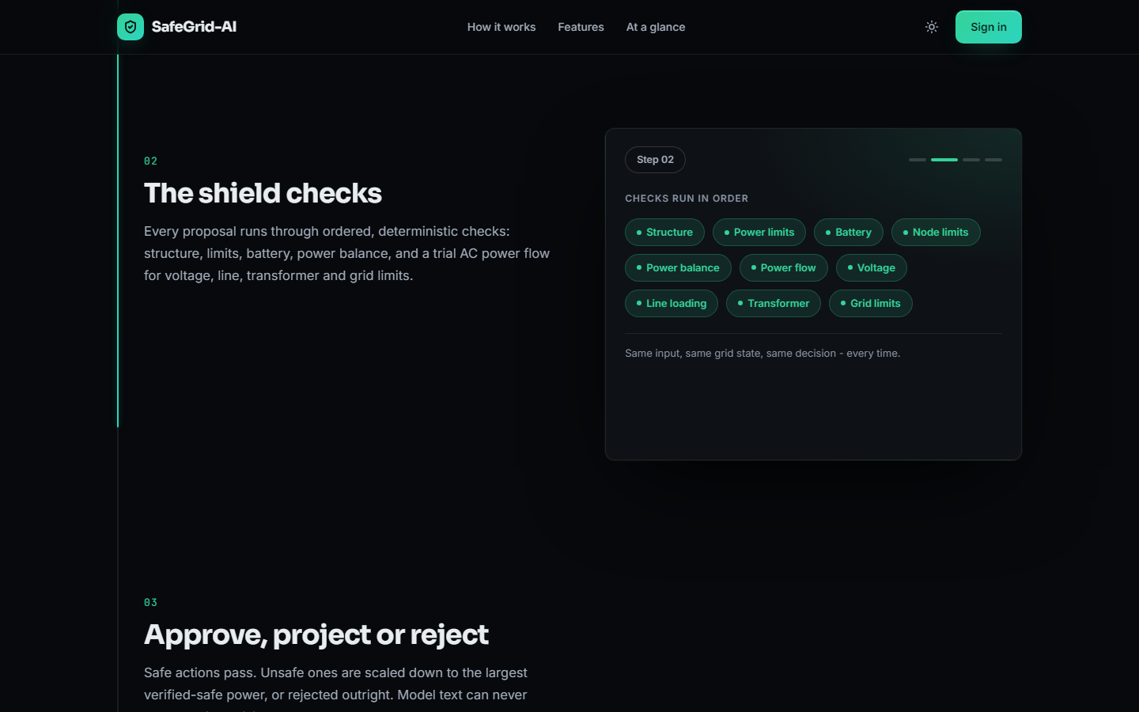
Figure 33: The "How it works" section: the ten ordered shield checks
A scroll story walks through the pipeline. The capture shows the second step, the ten checks the shield runs in order (structure, power limits, battery, node limits, power balance, power flow, voltage, line loading, transformer, grid limits) and the statement that the same input and the same grid state always give the same decision.
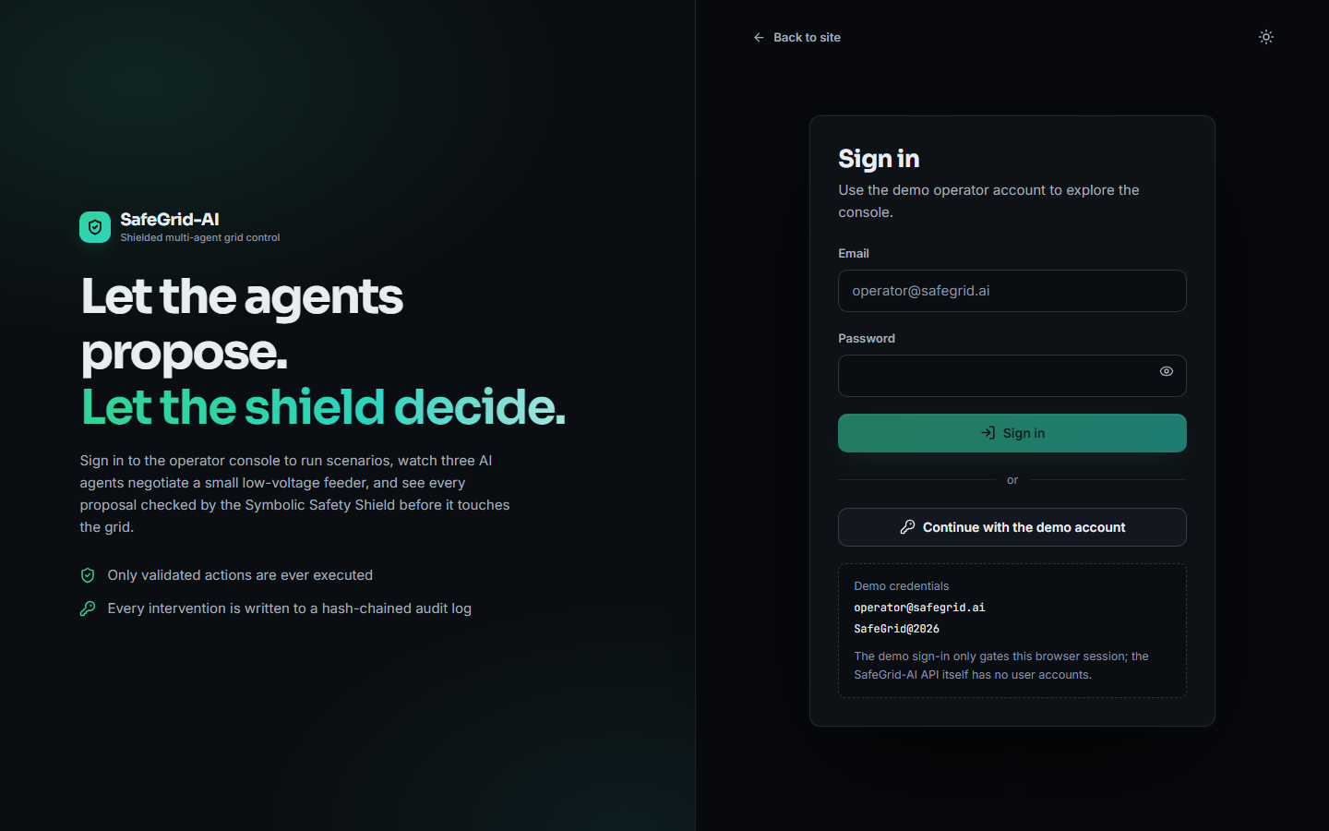
Figure 34: Sign-in screen with the demo account
The sign-in offers an email and password form and a button for the demo account. The panel under the button shows the demo credentials and states that the sign-in only gates the browser session and that the API has no user accounts.

